To develop **communication and language and personal, social and emotional learning** we have created a family box that the children will take turns taking home. When the box returns **we will discover and learn new things about all the children** in Emerald Class!

As part of our Early Years curriculum we teach the children to **understand and appreciate our differences and similarities**. We all have different ideas, cultures, beliefs and needs that should be valued and treated with respect.

The box will **go home on a** **Friday** so you can fill it up over the weekend. It will return and stay in school from Monday to give your child a chance to share and talk about their special things throughout the week.

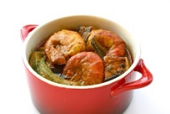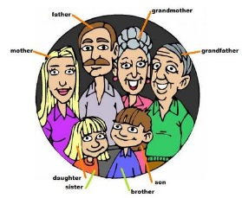

Your child could put…

Examples of **food** that you eat at home (packets, boxes, photos)

Your child could put…

Christening or Baptism 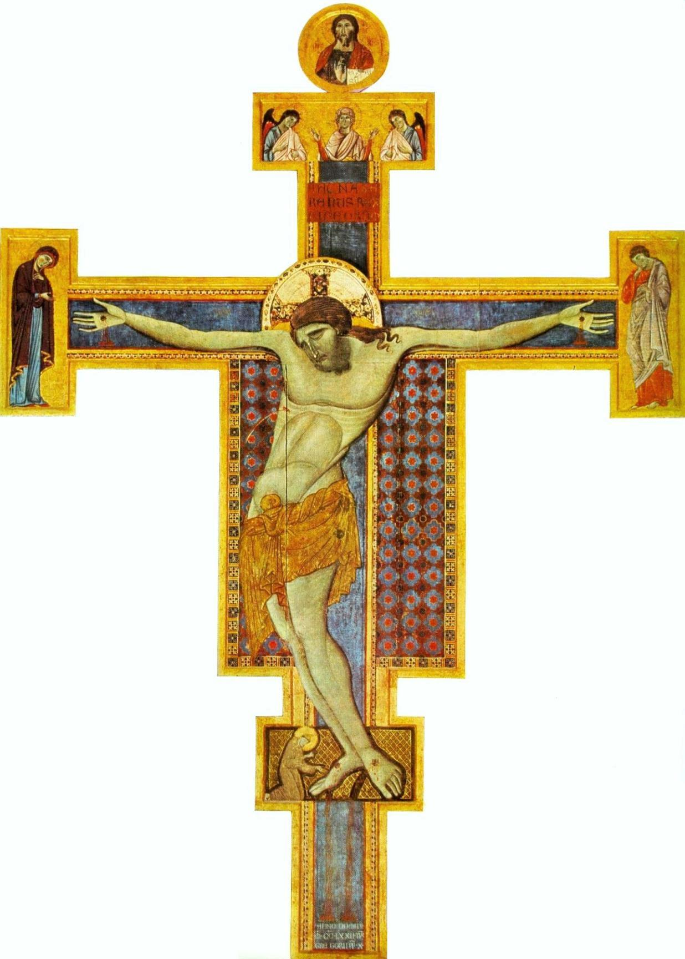certificates, or any information about your **place of worship**.

Your child could put…

Information about the members of **your family.**

Your child could put…

Photos of **special events** e.g. holidays, birthdays or special days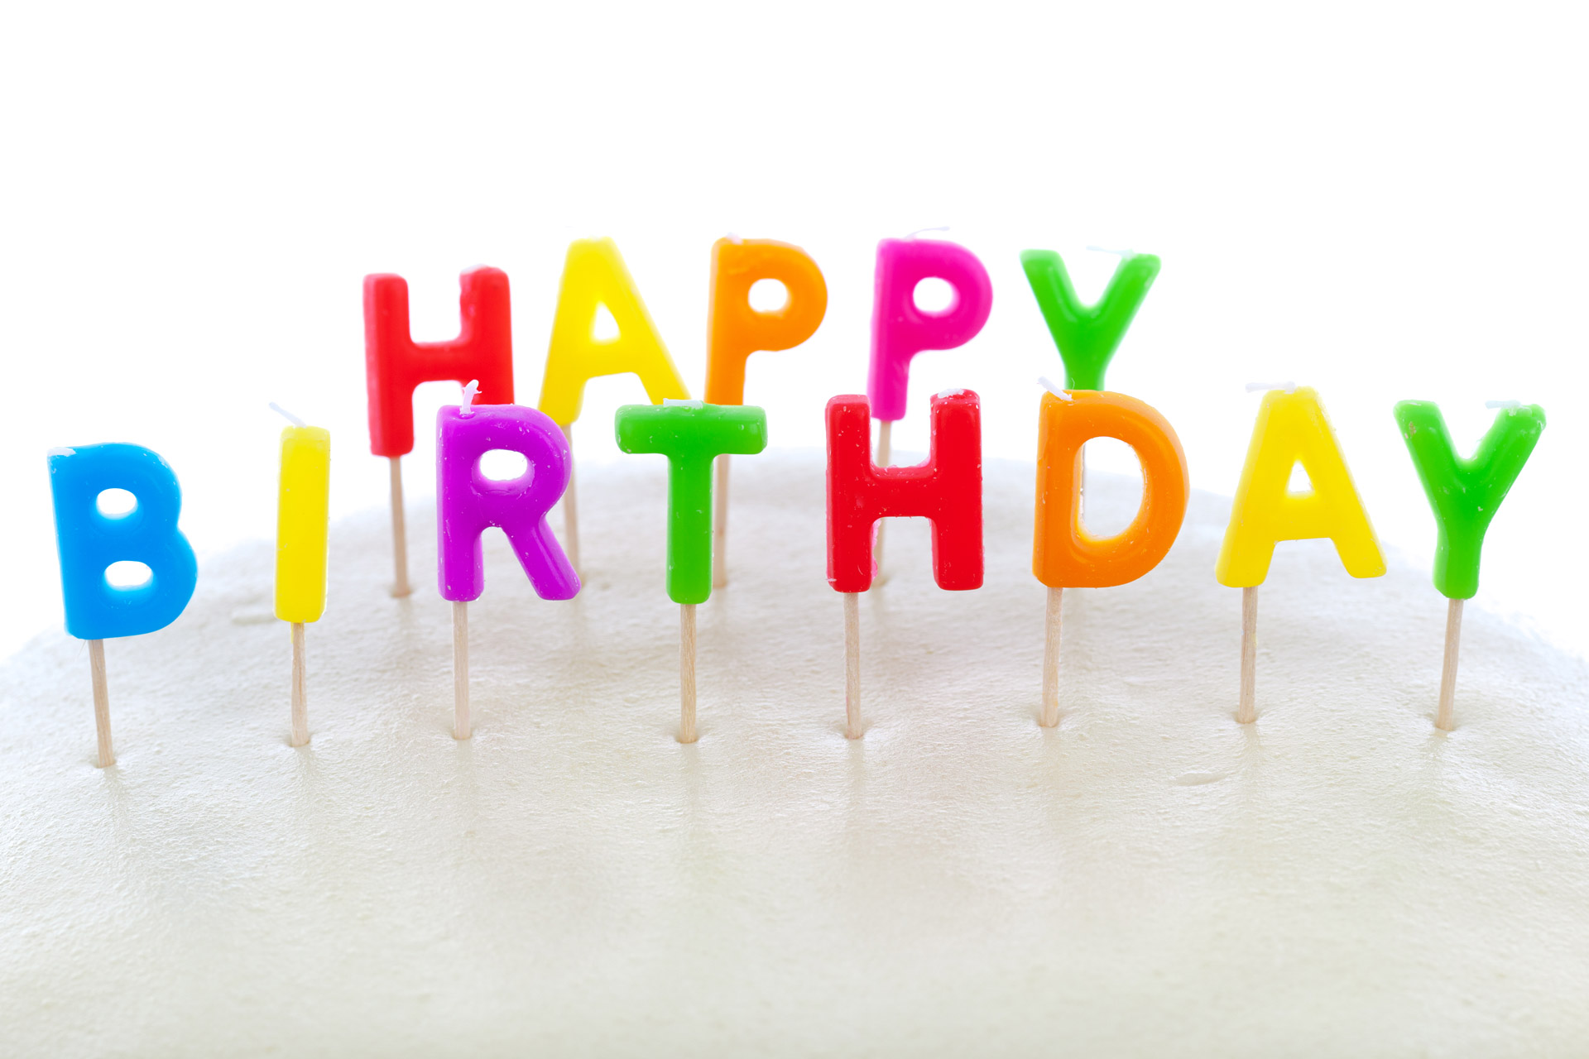

Your child could put…

Examples of **clothes** worn at home for **special occasions**.

Your child could put…

Any other **things important** to your family.

 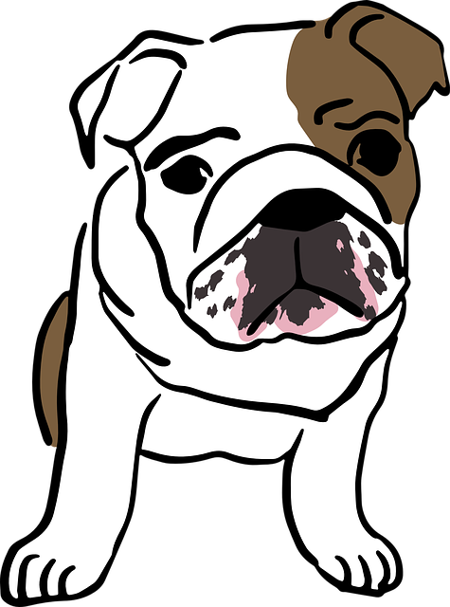

**Emerald Class**

**Family Box**

**To develop our personal, social**

**and emotional learning**

Your child could put…

Favourite **books** or **stories**.

