Pearl Class

All About Me
Spring 1

Communication & Language

- Respond to simple instructions
- Listen to stories and join in actions
- Use words and gestures to communicate
- Listen to others
- Ask questions
- Begin to distinguish some sounds

Literacy (Familiar stories).

- To join in familiar nursery rhymes
- Draw and paint giving meaning to marks
- To recognise & write own name
- Talking about family members and answering related questions
- Stories about different types of families
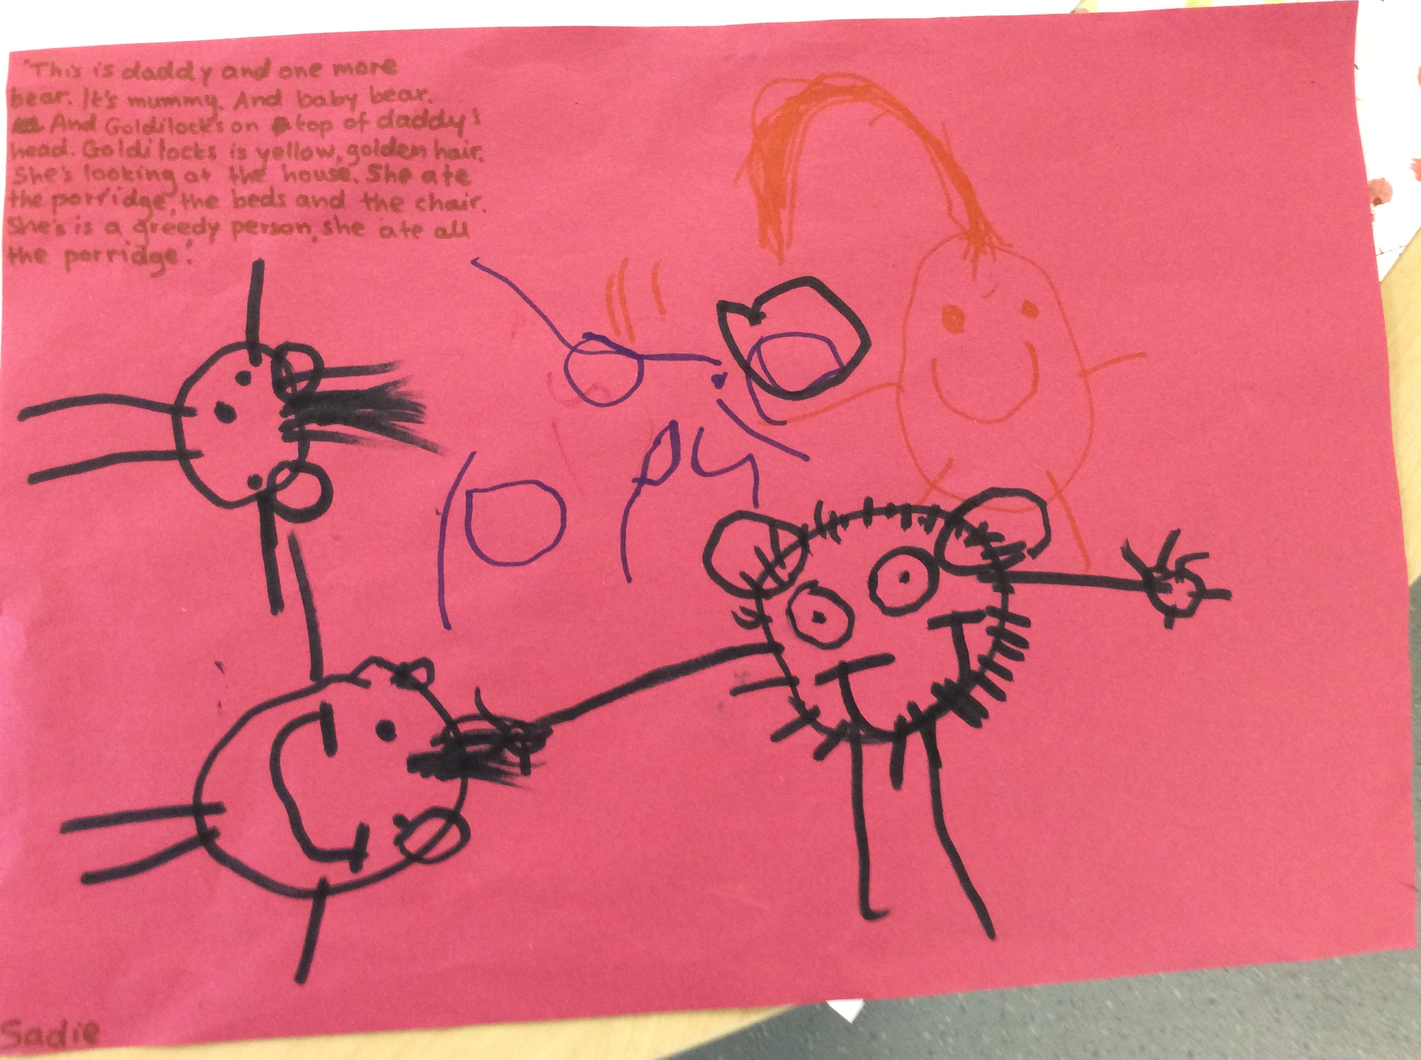

Mathematical Development.
- Counting objects and/or actions to 10 and then to 20
- Match number cards to numbers or amounts
- Finger rhymes
- Comparing 2 groups of objects
- Sort groups by types
- Comparing height, size and length

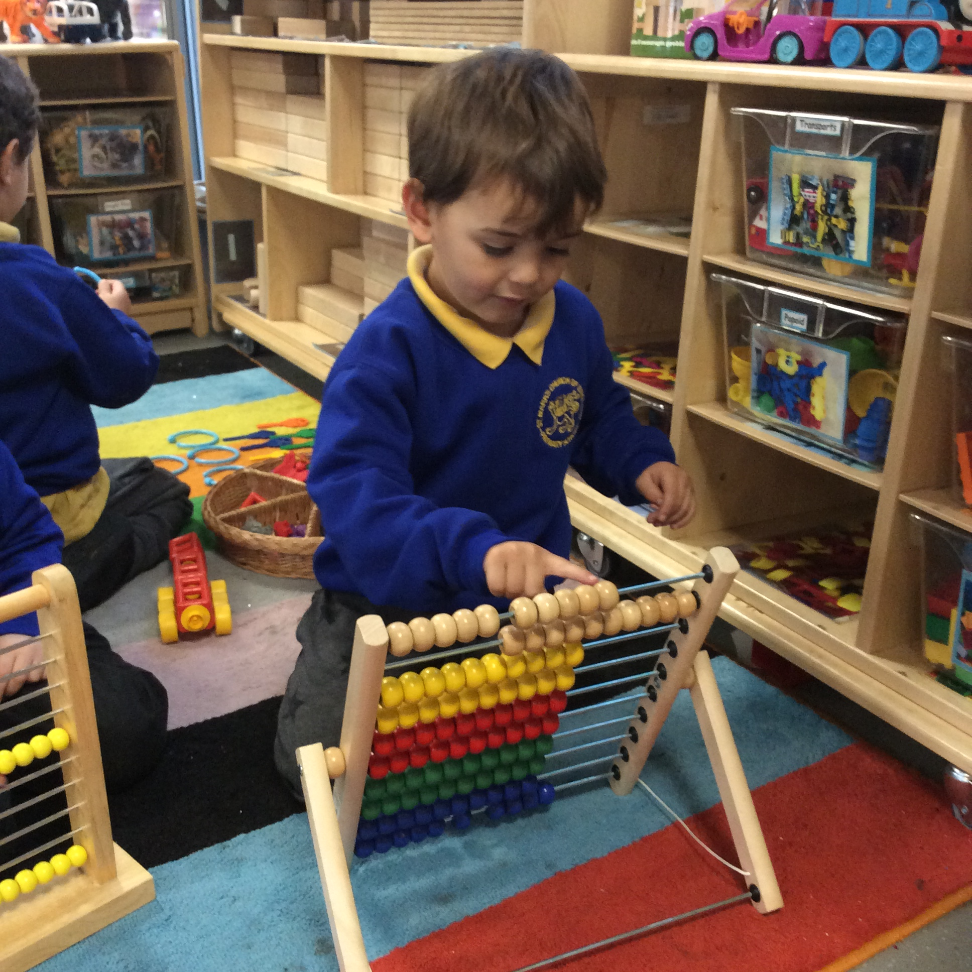

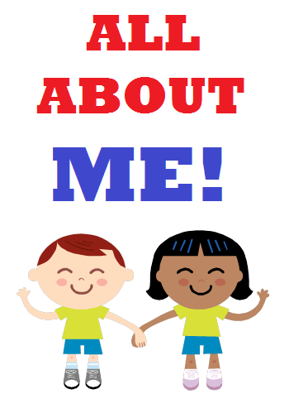
Knowledge and Understanding of the World.
- Explore construction
- Ask why things happen and how they work
- Use of ICT to support learning
- Create self –portrait
- Talk about self and family
- Explore celebrations
- Finding differences/similarities with other type of families

Expressive Arts & Design.
- To use tools safely
- Observational drawings/paintings of faces using mirrors
- Explore different materials/ textures to create collages of own face
- Explore music, sounds and sing songs

Personal, Social and Emotional Development
- Follow school rules and routines
- Take part in circle time and team activities
- Look at personal history ‘how have you changed?’
- Try out new activities and select resources independently
- Show awareness of own and feelings of others
- Talking about themselves and their likes/dislikes

Physical Development.
- Use small and large equipment and one-handed tools
- Promote fine motor control by using threading activities, puzzles and large/ small construction
- Move with control and co-ordination and in a range of ways
- Playing games in the pitch to adjust space , like running, jogging, jelly beans
- Talking about changes in their bodies

