

Weekly Overview – Week Beginning 16.10.17

**Here is an overview of some of the activities we will be doing this week, in whole class and small groups.**

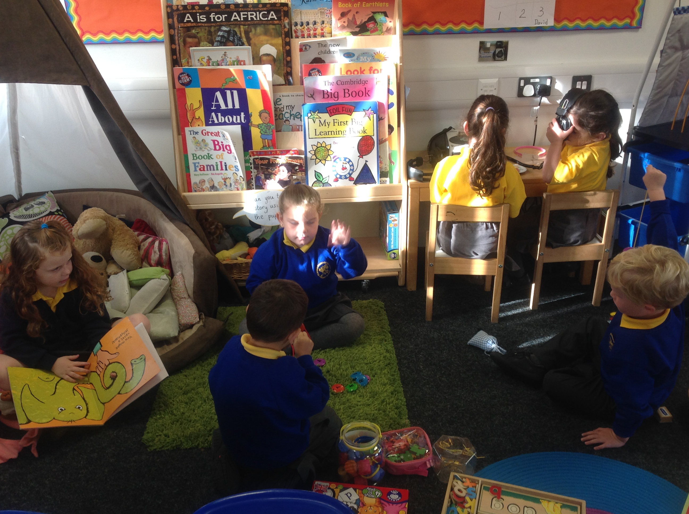

**Favourite Stories**

We would like to invite each child to bring in a favourite story from home to share with their friends.

Please remember to write your name in your book!

We will be reading lots of stories and discussing why we like them. We will also be talking about the characters, setting and main events in some stories

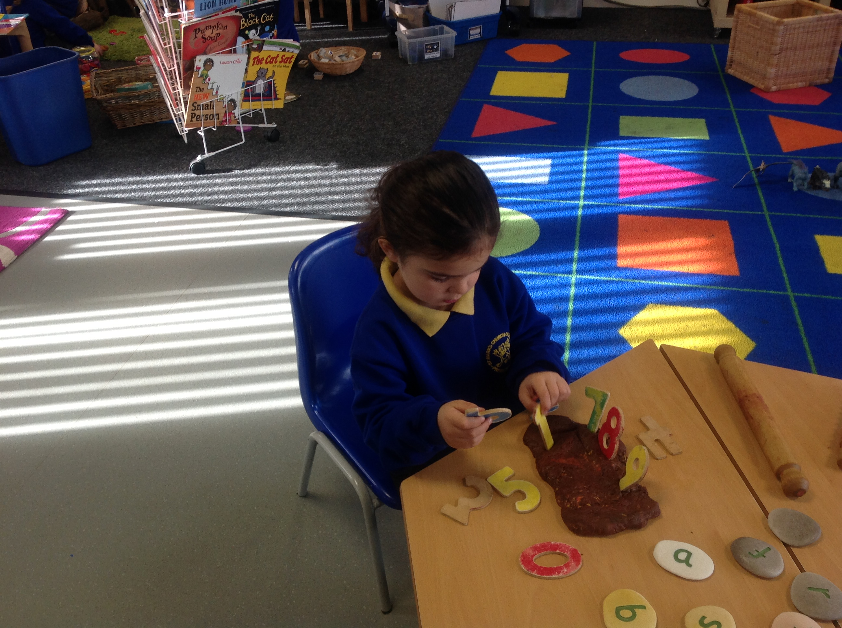

**Cooking**

We aim to cook with the children each week. If you are able to, please make a half termly donation in the class cooking money pot. Thanks

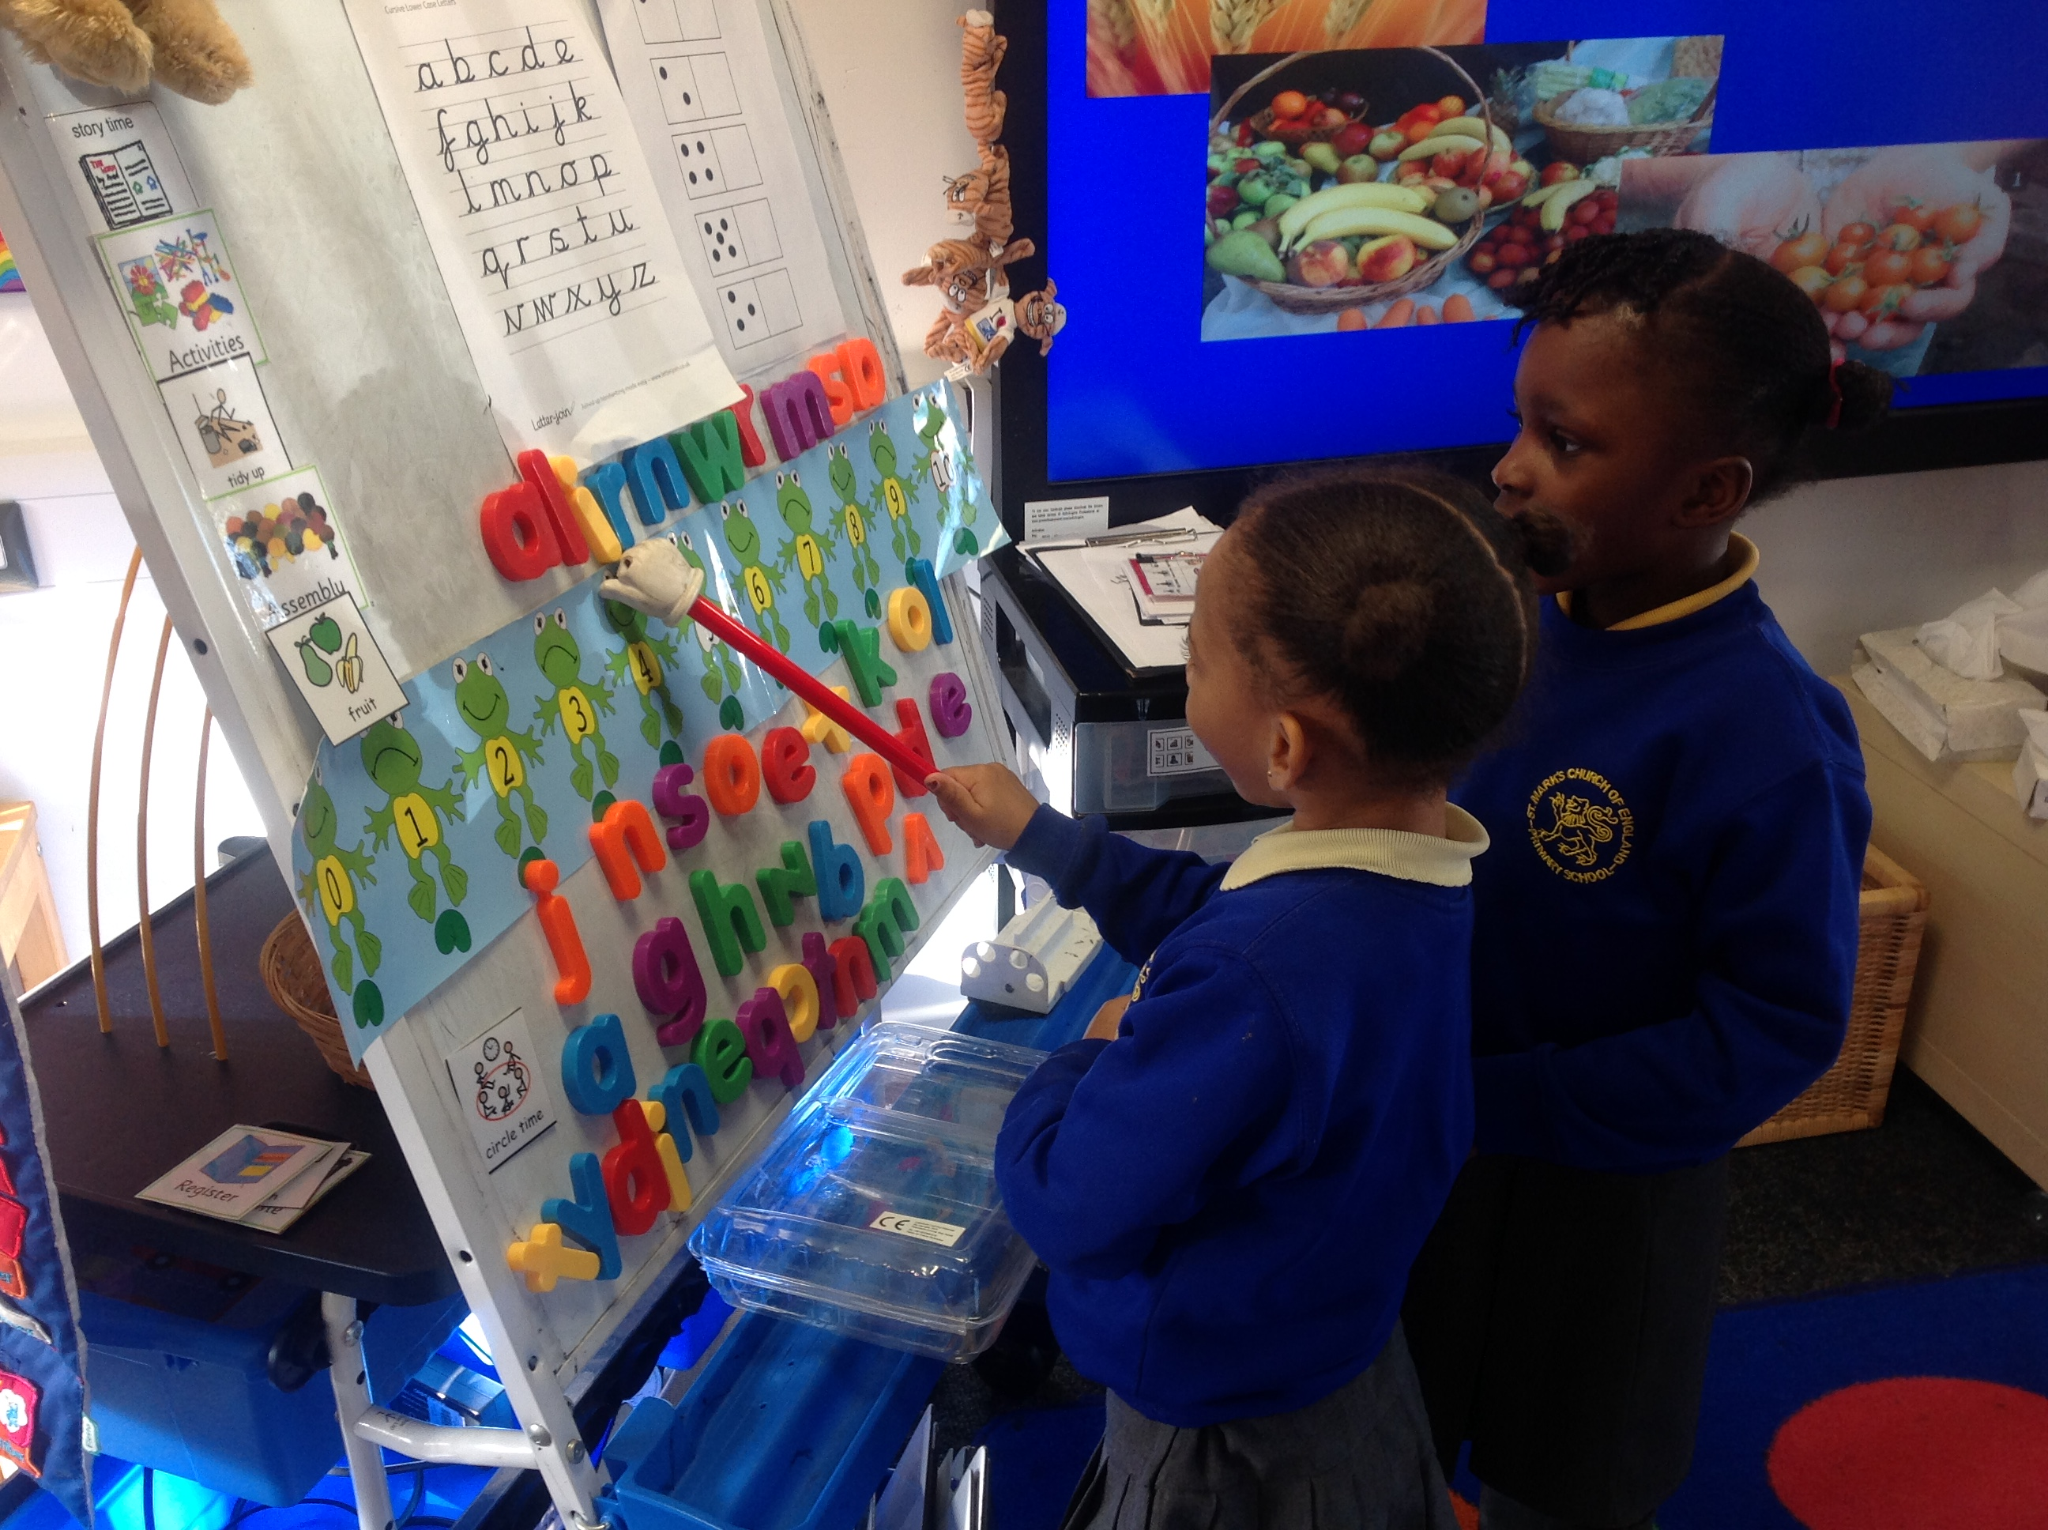

**Letter and Sounds**

This week we will be listening to sounds in the environment and practising identifying individual sounds. We will also be listening to and playing different musical instruments and discussing the sounds they make.

We will focus on the letter sound **s**, finding things beginning with this sound and looking at some words beginning with this sound.