

Weekly Overview – Week Beginning 27.11.17

Here is an overview of some of the activities we will be doing this week.

**Fairy tales**

This week ‘We are going on a bear hunt’! We will be singing and planning ways of reaching the scary Bear’s cave!

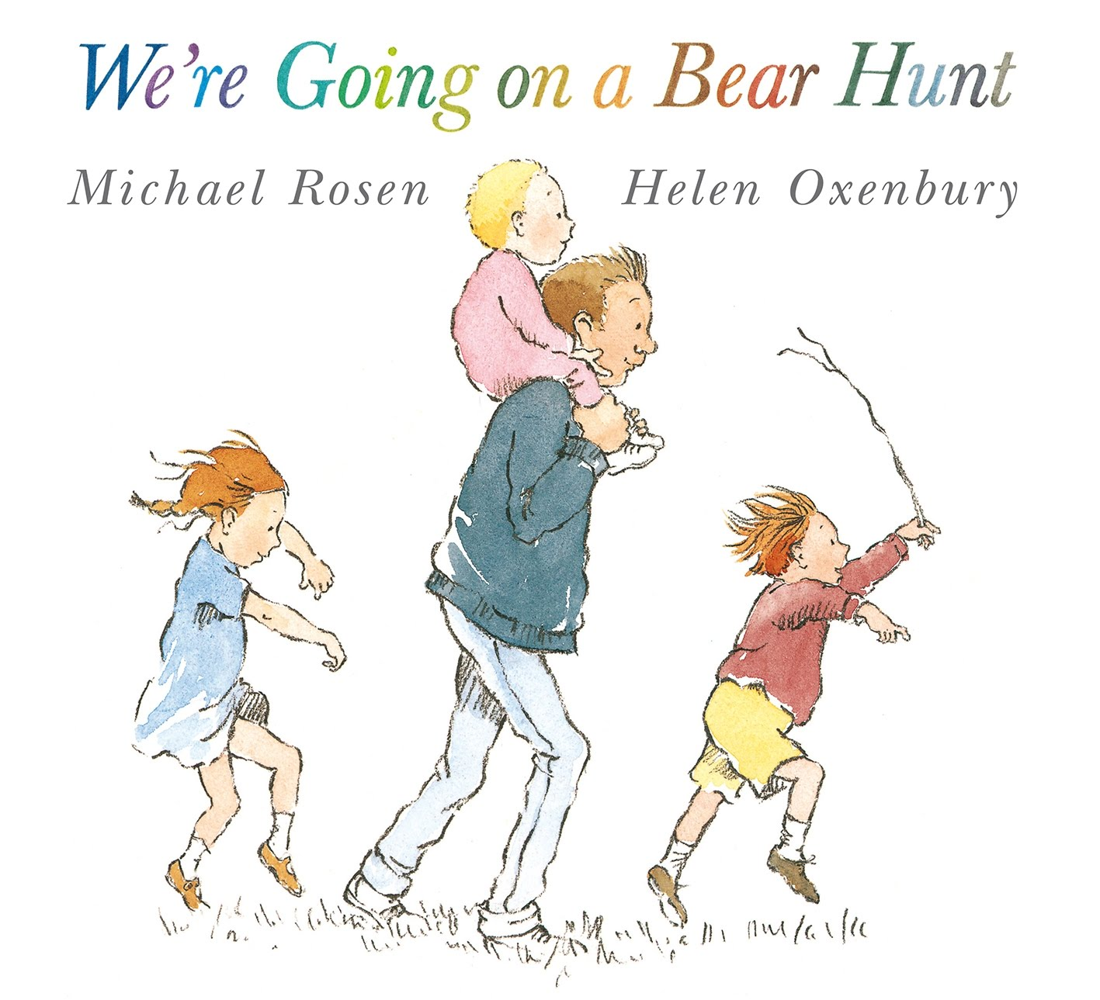

**Maths**

We will be working on understanding terms like over, under and through.



**Literacy:**

We will encourage the children to repeat refrains from the story.

**Writing:** We will encourage the children to make a map of their journey to the cave.

