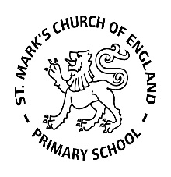

Weekly Overview – Week Beginning 6.11.17

**Here is an overview of some of the activities we will be doing this week, in whole class and small groups.**

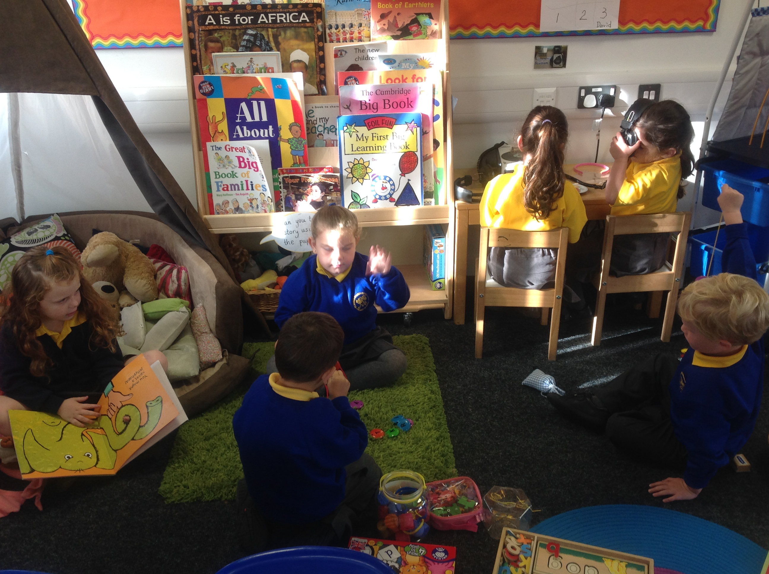

**Favourite Stories**

This week will be focusing on the book ‘Tanka Tanka Skunk’, by Steve Webb. We will talk about the animals in the book and also think about any other animal books and stories we know. The children will have a go at painting and collaging some of the animals from ‘Tanka Tanka Skunk’.

We will practise clapping the rhythms in the story, and then also have a go at clapping the syllables in our own names.

We will also be playing some animal board games to practise counting and recognising numbers to 20.

**Parents’**

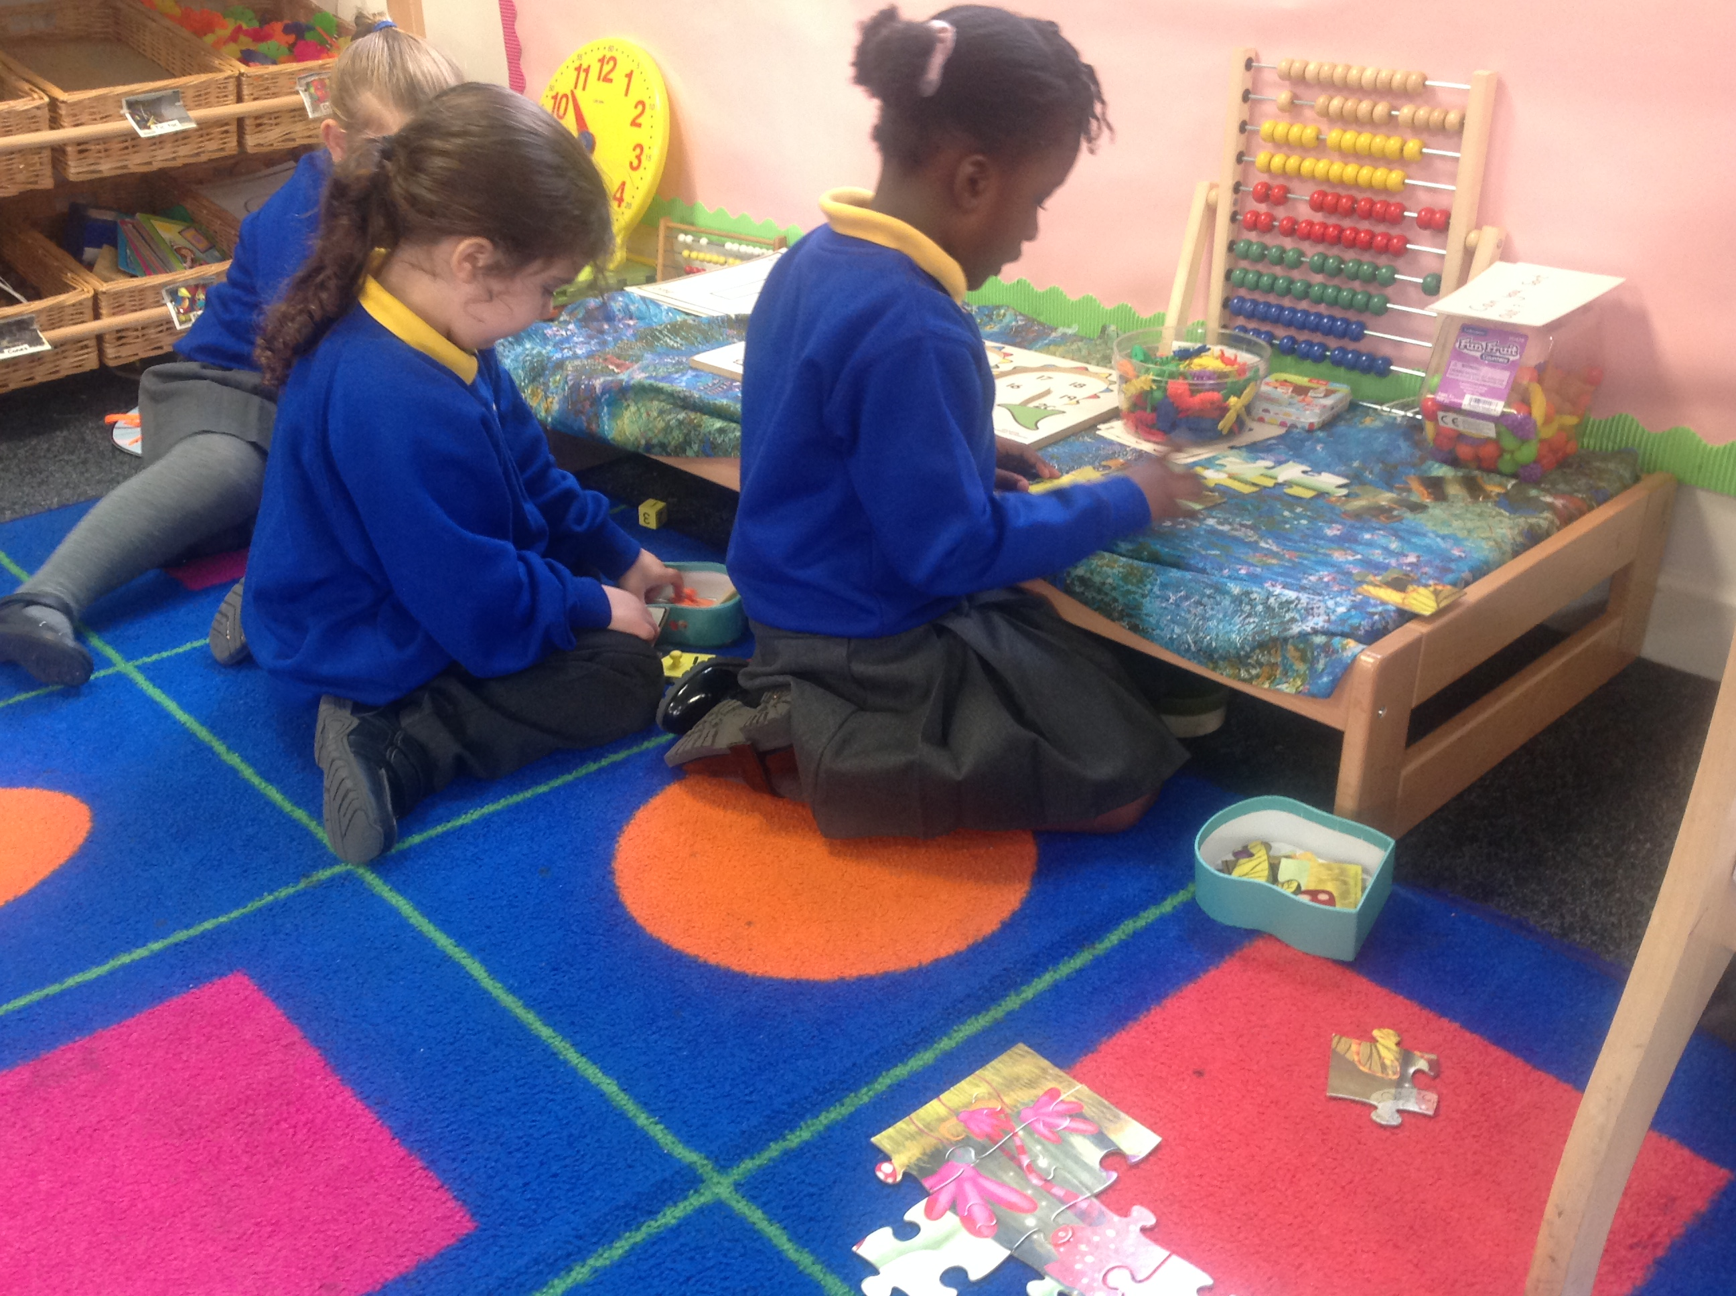

**Number**

We will also be playing with animals and board games to practise counting and recognising numbers to 20.

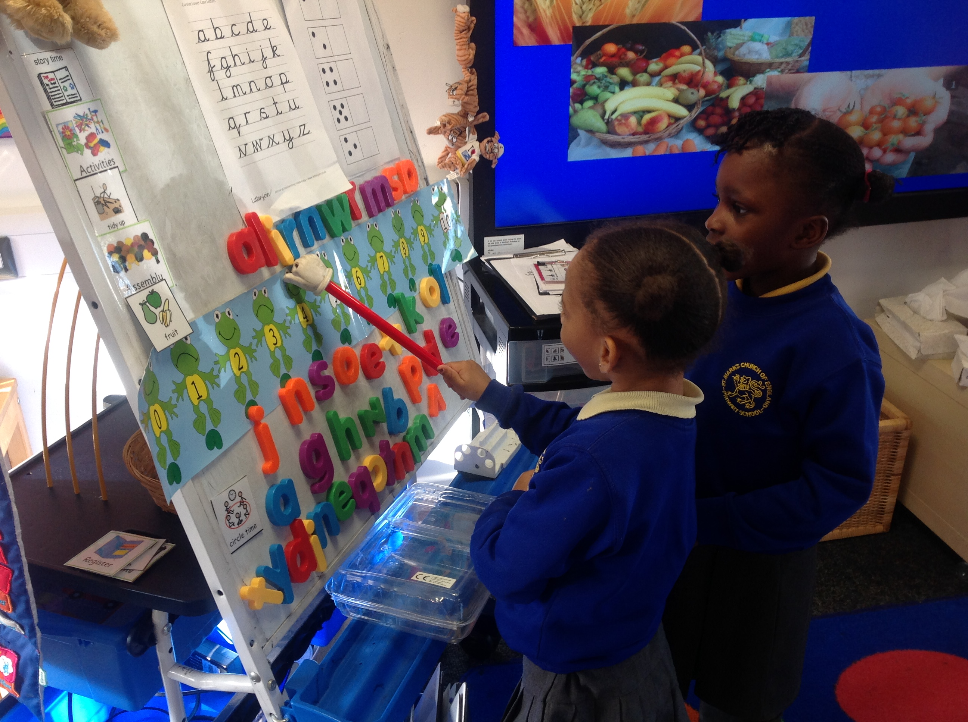

**Letter and Sounds**

This week we will be learning the sounds: **p**

**i** and **n.** We focus on the sounds the letter makes, not the letter name - so **i** as in **i**gloo, **n** as in **n**est. We will also be practising blending sounds together to form words, by saying the individual letter sounds first until we can hear the whole word, for example: p - i - n = pin