

Weekly Overview – Week Beginning 04.12.17

Here is an overview of some of the activities we will be doing this week.

**Traditional stories**

Pearl class are enjoying the story ‘We are going on a bear hunt’ so much that we have decided to carry on with even more fun activities linked to this story.

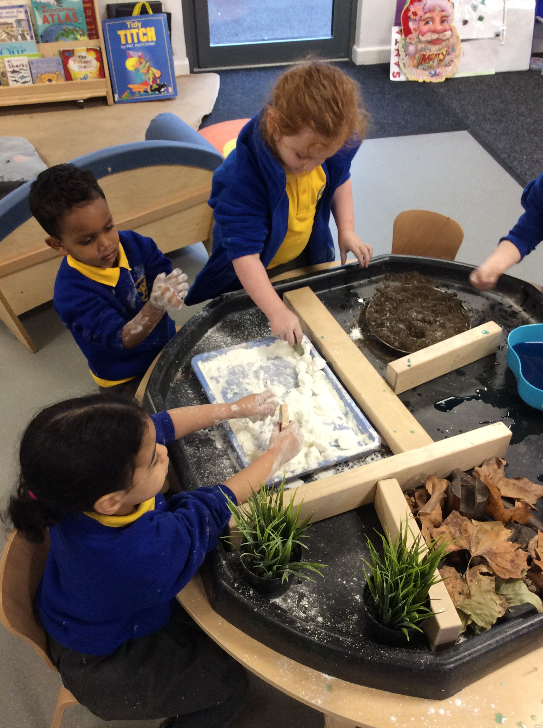

**Maths**

We will be working on learning and using positional language.

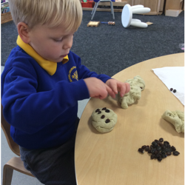

**Literacy:**

We will encourage the children make up their own ‘hunting’ story.

**Phonics:**

The children will learn about instrumental sounds.

**Writing:**

The children make a map of their own hunt journey.

