

Weekly Overview – Week Beginning 11.12.17

**Here is an overview of some of the activities we will be doing this week, in whole class and small groups.**

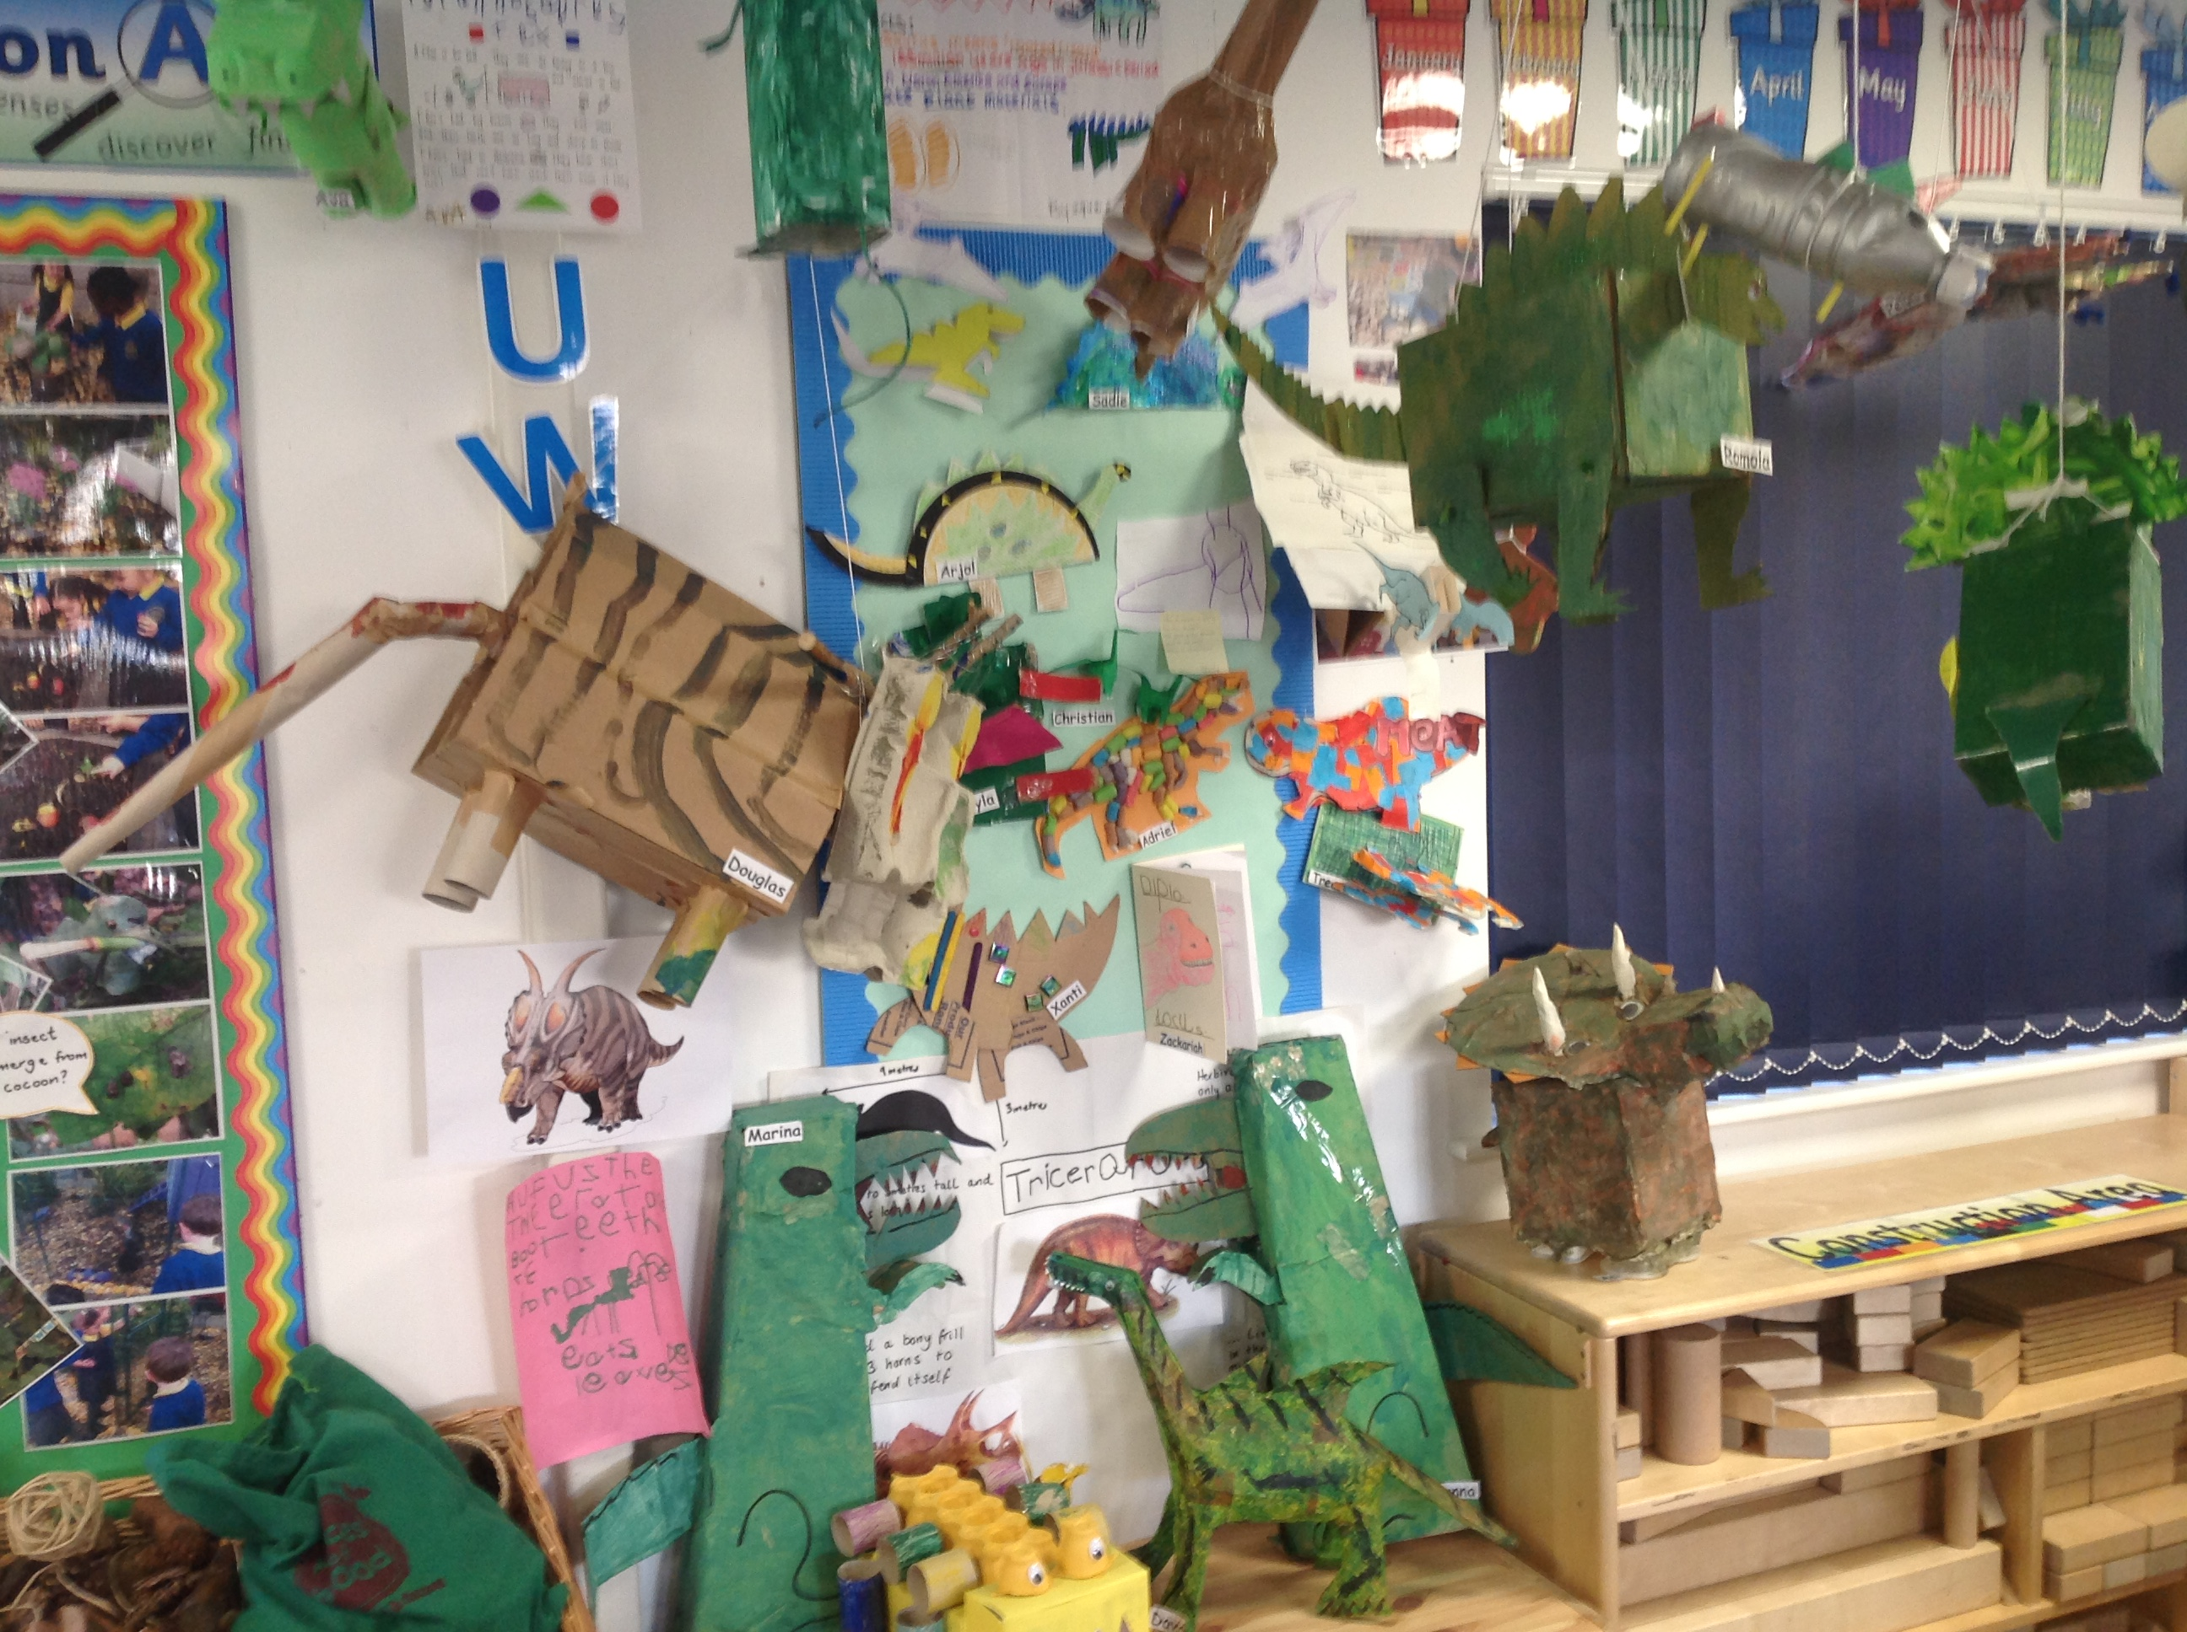

**Maths**

This week we are continuing to focus on counting and recognising numbers to 20, particularly focusing on numbers 11-20. We will use a variety of tools to help the children to understand the value of these numbers.

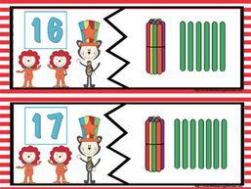

**Letters and Sounds**

This week we are learning the sounds ‘h’, b, f’ and ‘l’. We will be looking at the written letters and thinking about words that start with these sounds. We will also continue to write CVC words, e.g: hat, cat, pen, and cap and simple sentences.

**Tricky Words**

This week we will be revising our tricky words.

