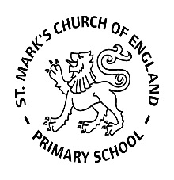

Weekly Overview – Week Beginning 26.2.18

Here is an overview of some of the activities we will be doing this week, in whole class and small groups.

Introducing Our New Topic

Space



**Maths**

## This week we will be practising recognising numbers 10 –20, using Numicon and playing games. We will also look at various pictoral representations of these numbers, to help develop the children’s understanding of their values.

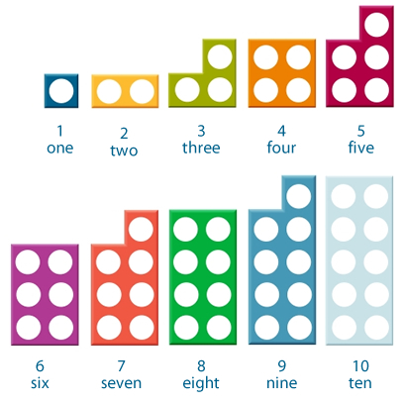

**Letters and Sounds**

This week we will be learning the sounds: W (web) and y (yes) .We are also playing lots of games to practise blending simple words, e.g: c-a-t = cat. We encourage the children to repeat the sounds, getting a little faster each time, until the sounds blend together and they can hear the whole word.

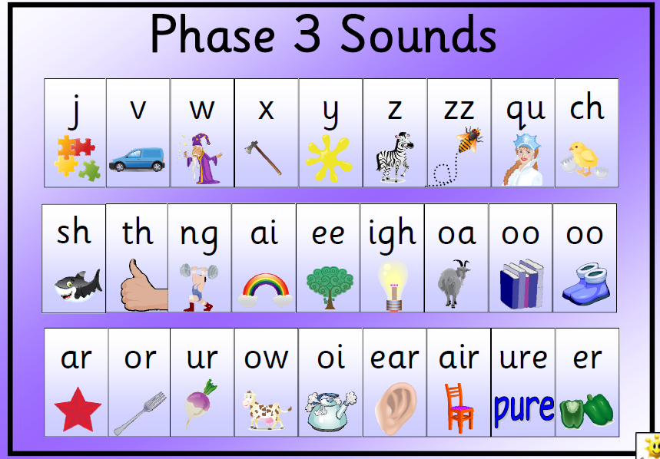

**Tricky Words**

This week we will be revising our tricky words, go, I, to, the, no, into.