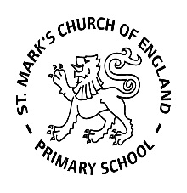

Weekly Overview – Week Beginning 5.2.18

Here is an overview of some of the activities we will be doing this week, in whole class and small groups.

**Topic**

This is our last week on our topic all about dinosaurs. The children will be celebrating on Wednesday with a final piece of writing and a party with volcanos as well as enjoying a lovely dinosaur cake.

**Please make sure your volcano is in by Wednesday.**

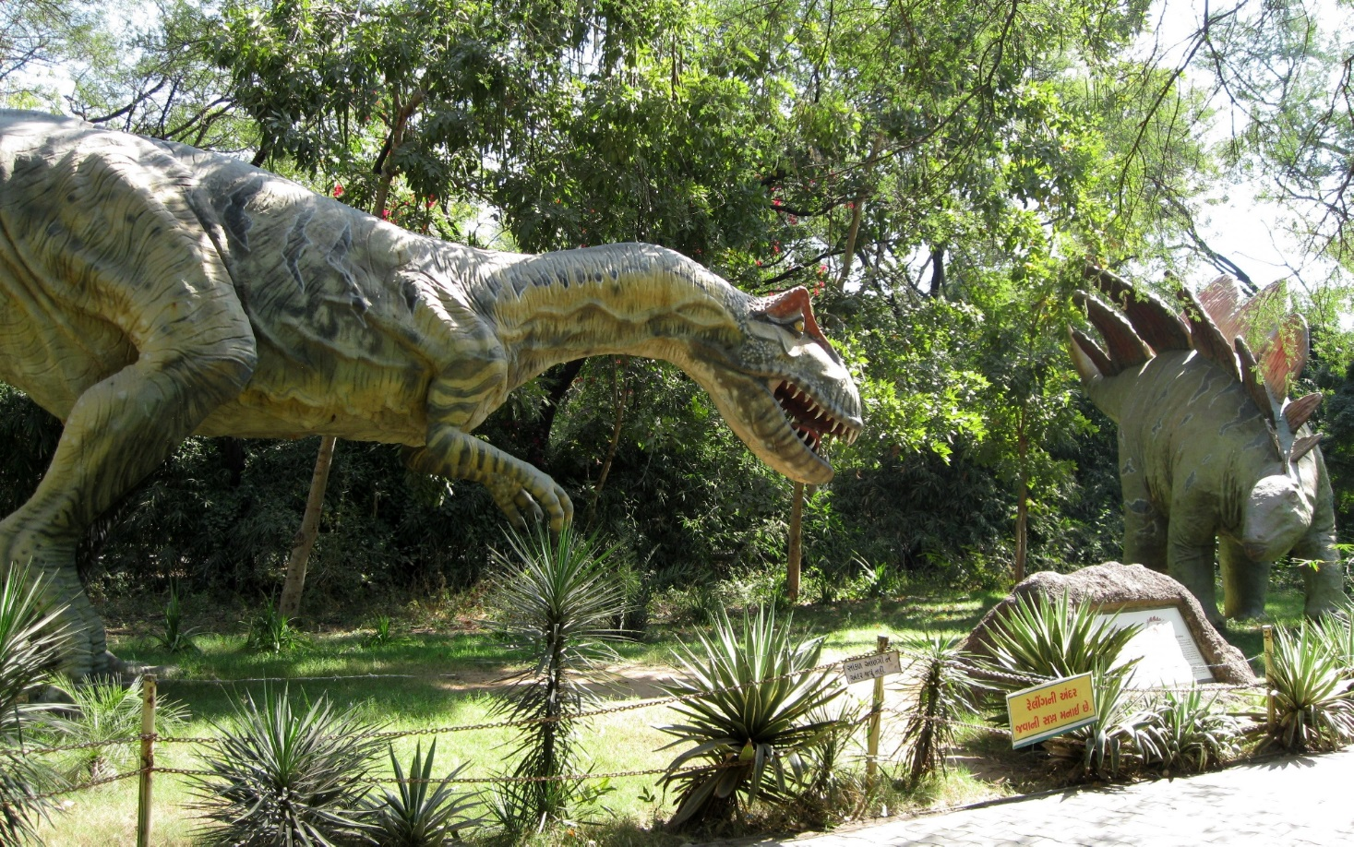

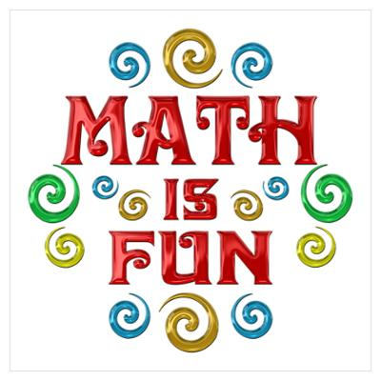

We are continuing to focus on weighing and measuring. We will be using lots of everyday language about size, length, height and weight. We will also be ordering items by length and weight. The children will have lots of opportunities to explore capacity with water and sand.

.



**Letters and Sounds**

This week we want all the children to bring in a photograph of someone who is special to them.

They will then use their knowledge of letters and sounds to write why they are special.

**Please bring in the photograph on Monday.**



