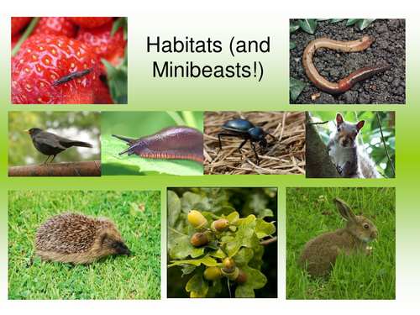
St. Mark’s CofE

Mini-beasts & Plants
Summer 1
Understanding of the World
- Life cycles of butterflies, frogs and plants
- Where mini beasts live - habitats
- Identifying changes from the beginning until the end of a flower/plant
- Minibeast hunts
- Looking at similarities and differences of mini-beasts
- Using internet to find out more about mini beasts
- Construction models of insects using Duplo & Interstar
Expressive Arts and Design
- Observational drawings of mini beasts
- Insect masks and models
- Using and mixing colours to create flowers
- Looking at camouflage
- Small world play – variety of habitats e.g. zoo, jungle, farm, forests, woods, etc
- Mini beasts songs
- Role play ‘Little Gardeners’
Communication, Language & Literacy
- Role play – ‘The very hungry caterpillar’, ‘the bad tempered ladybird’, etc.
- Naming mini beasts and plants, learning related vocabulary
- Songs about mini beasts e.g Incy Wincy spider
- Making booklets – Who lives here? lift the flaps, information books about insects
- Posters for mini-beast hunting
Mathematical Development
- How many insects can you find?
- Sorting mini beasts & insects into groups e.g. how many legs?
- Sorting out by size and species
- Measuring insects
- Symmetry of insects & flowers
- Problem solving – arranging insects on 2 leaves
- Counting using flowers and their petals
- Making flowers using shapes
Personal, Social & Emotional Development
- Looking after mini beasts & plants
- Show care and concern for animals and the environment
- Feelings about insects e.g. fear of spiders
- Circle time talking about living things and how to protect them
- Sharing our feelings about making efforts to grow up a flower/tree
Physical Development
- Moving like mini beasts, e.g. jumping and crawling
- Junk modelling to make mini beasts
- Healthy eating
- Helping with dressing up, e.g. zipping up their coats

Books
The very hungry caterpillar
The Very Busy Spider
The Bad Tempered Ladybird
Non-fiction books
Miss Muffet
The incredible growing plant
Two frogs

