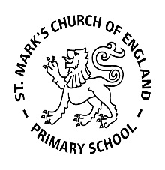

Weekly Overview – Week Beginning 28.10.19

Here is an overview of some of the activities we will be doing this week.

**‘Fairy Tales’**

This half term we will be looking at traditional fairy tales. We will be planning our activities around each book.

During the topic there will be some fantastic opportunities to retell stories through role play and puppets to develop children’s imagination, talk about the characters and their feelings and develop an understanding of the moral of the story.

The book we are reading this week is ‘Goldilocks and the Three Bears’.

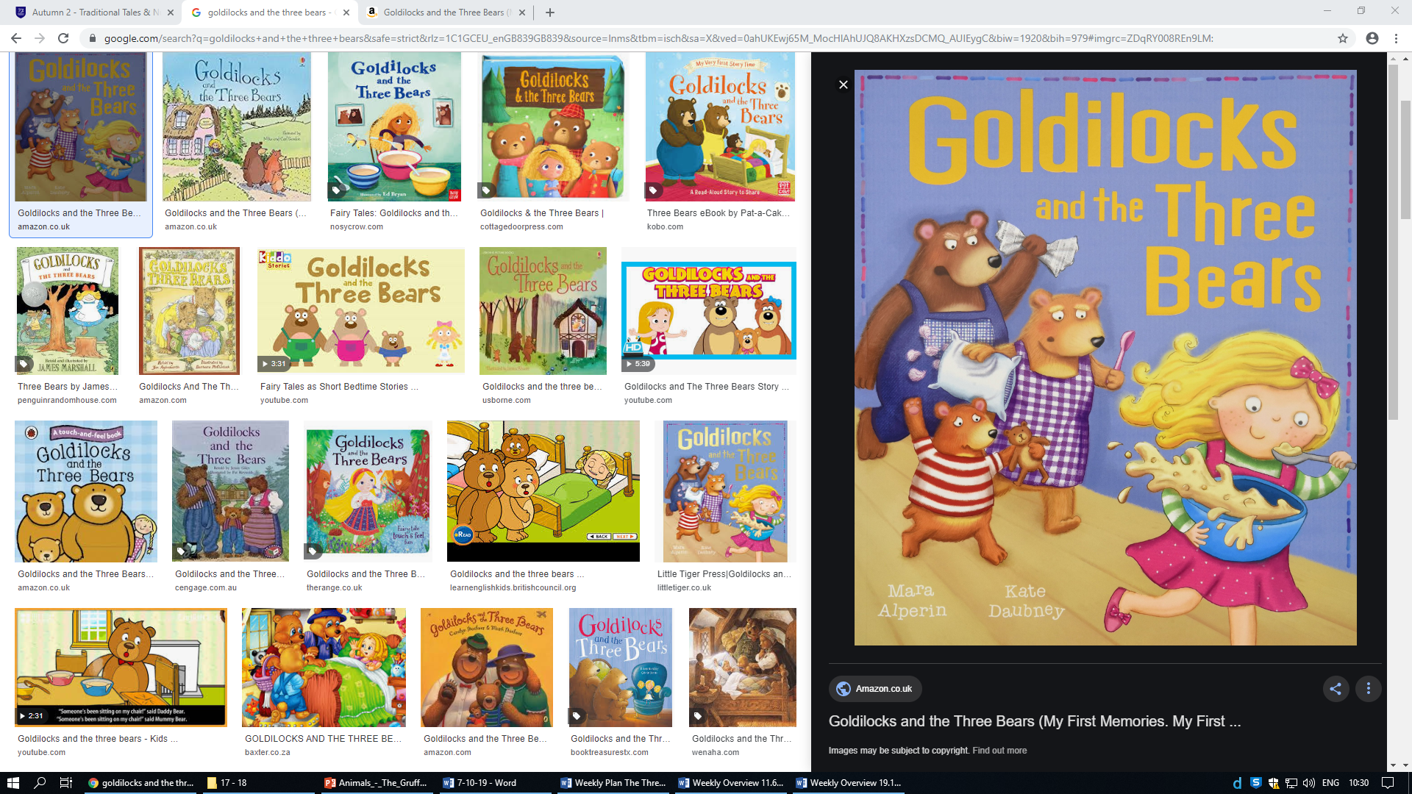

**Literacy:**

We continue to play lot of phase 1 phonics gams and some children have started Phase 2 Phonics sounds. The 2 sounds we are focusing on this week are ‘s’ and ‘a’. We will play lots of fun games to help us to remember these sounds!

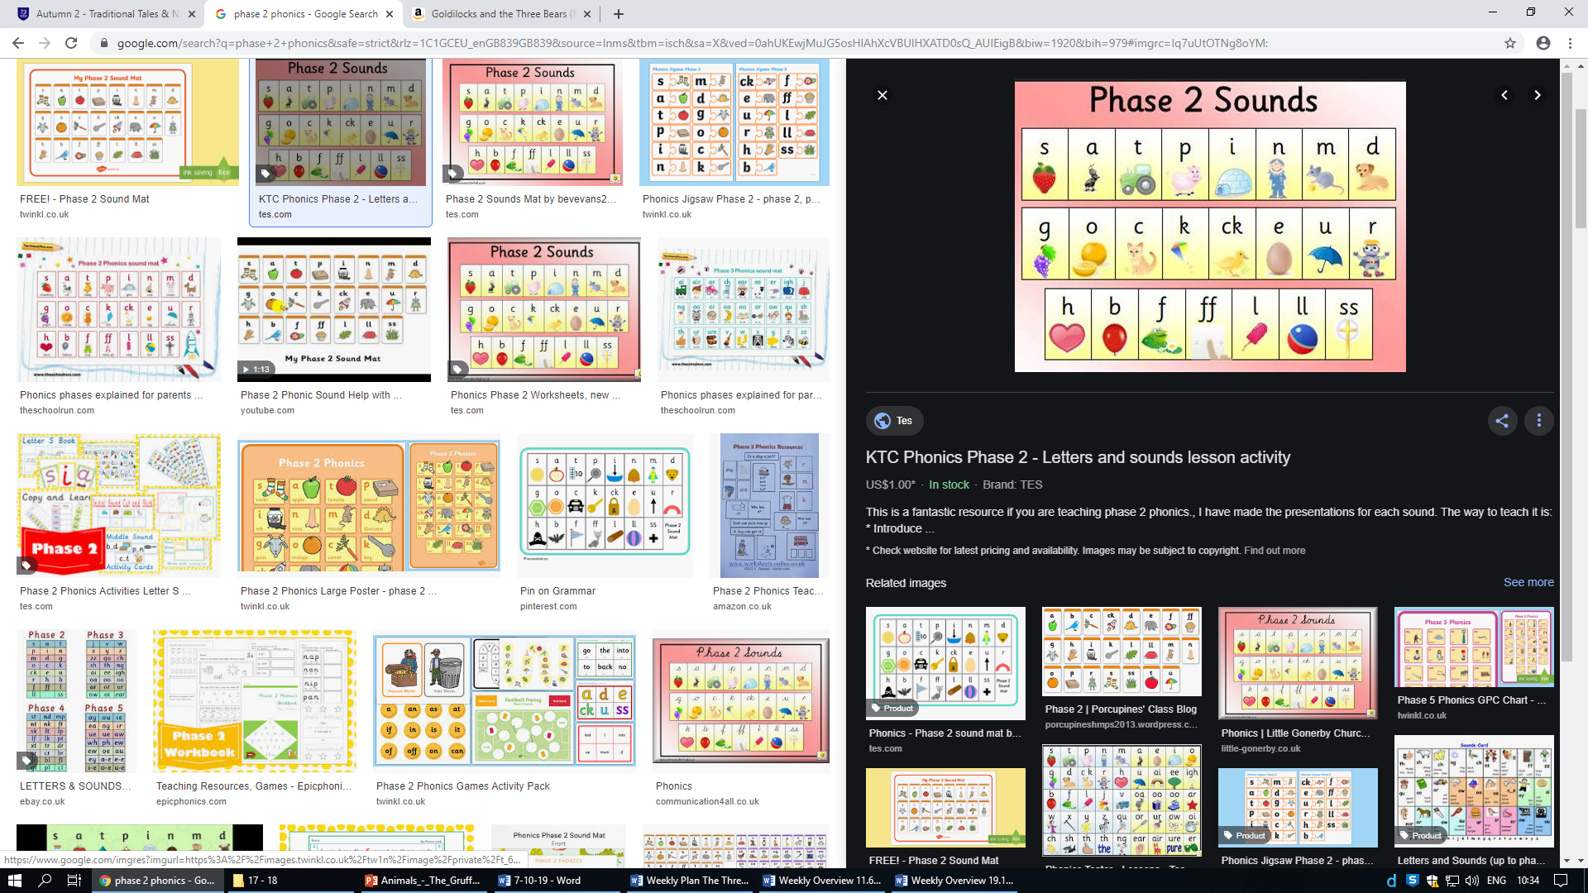

**Maths**

We enjoying learning our numbers through nursery rhymes. We will be ordering numbers 1-3 and 1-5 during circle time. We will also be talking about sizes and ordering bowls and bears from smallest to biggest.

Nursery Rhymes of the week:

This Old Man

Three Little kittens

