

Weekly Overview – Week Beginning 7.10.19

Here is an overview of some of the activities we will be doing this week.

**Black History Month**

This week we are focusing on Black History Month, exploring African/Caribbean heritage through music, food, art and dancing.

The children will be making fruit salads using exotic fruit.

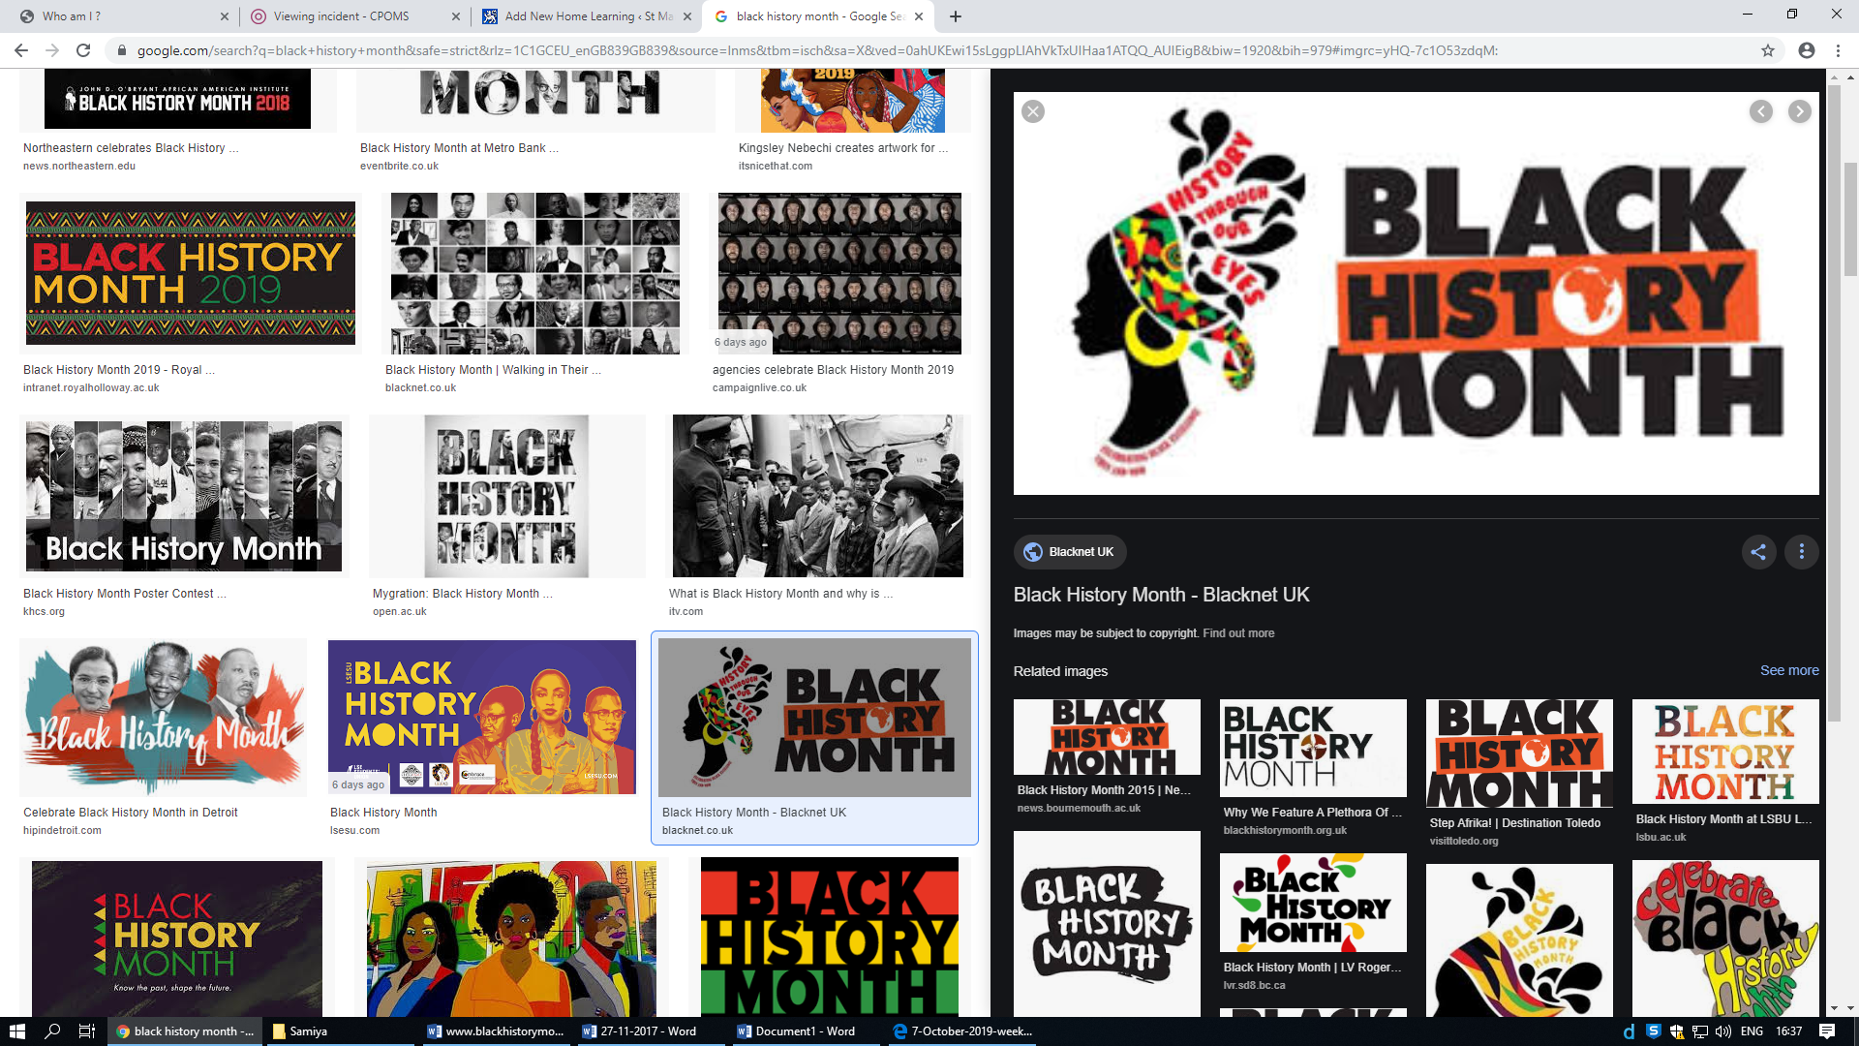

**Maths**

1,2,3,4,5…

Once I caught a fish alive!

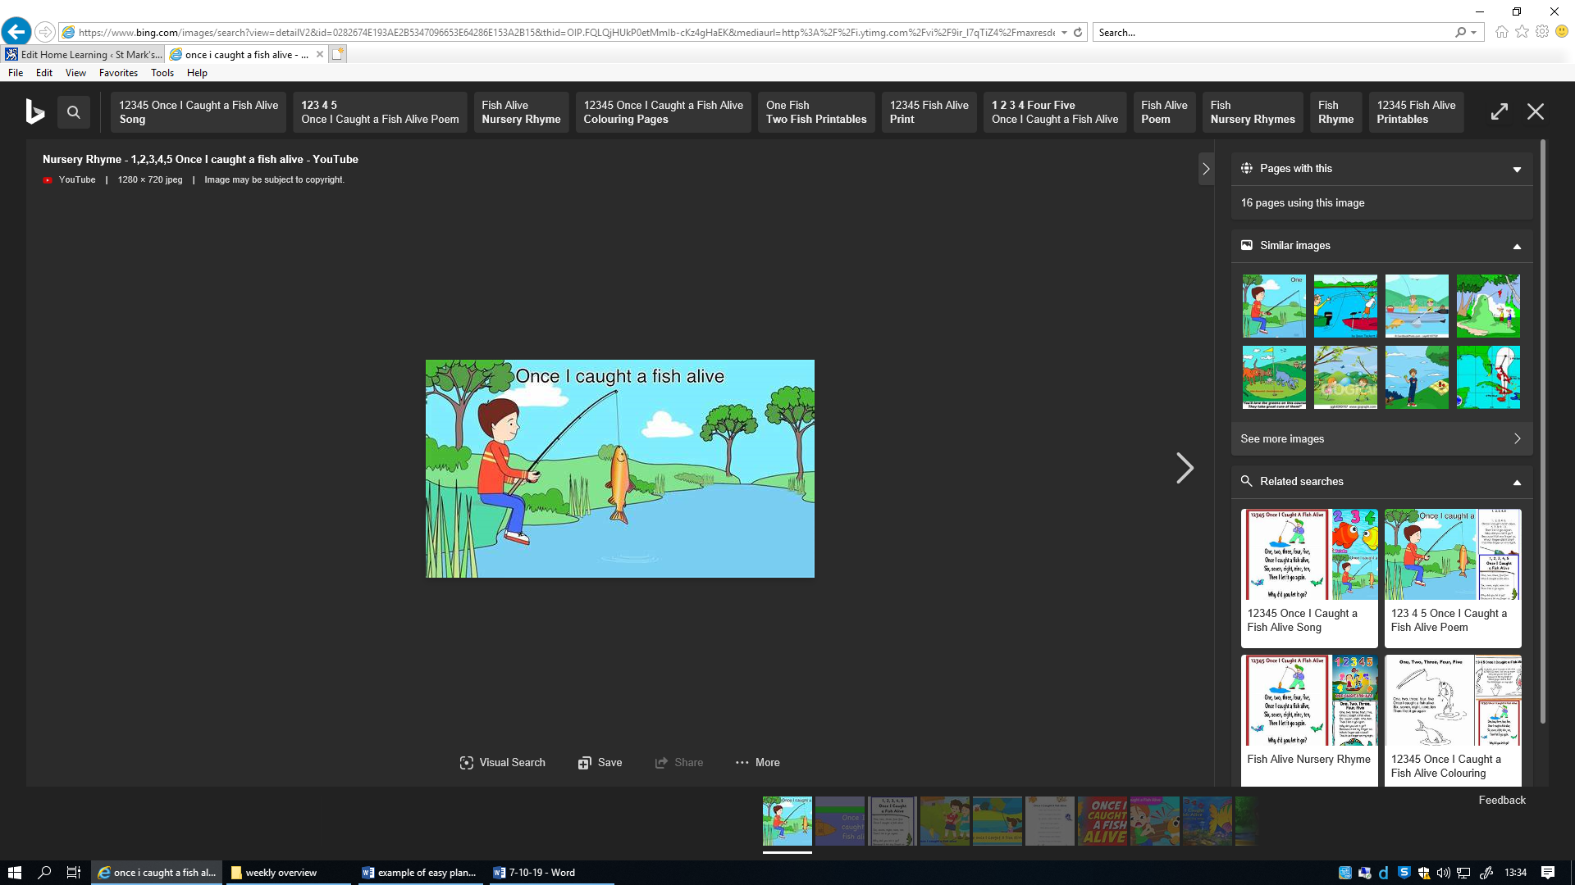

We will continue learning our numbers through nursery rhymes.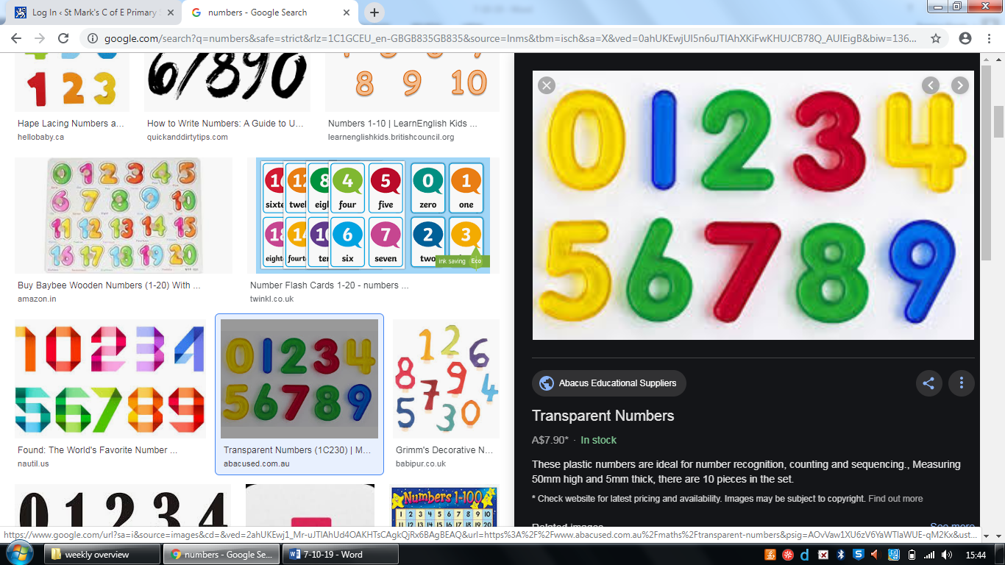

**Literacy:**

We will encourage the children to repeat refrains from the story.

**Writing:** We will encourage the children to mark make and give meanings to their marks.

