Pearl Class
Settling in / All About Me
Autumn 1

Communication & Language

- Respond to simple instructions
- Listen to stories and join in actions
- Use words and gestures to communicate their own needs
- Develop listening skills
- Encourage commentary through their/other’s play

Mathematical Development.
- Recognise numbers relevant to them
- Exploring numbers
- Building models (using language)
- 2D shapes
- Finger rhymes
- Comparing 2 groups of objects
- Sorting
- Comparing height, size and length

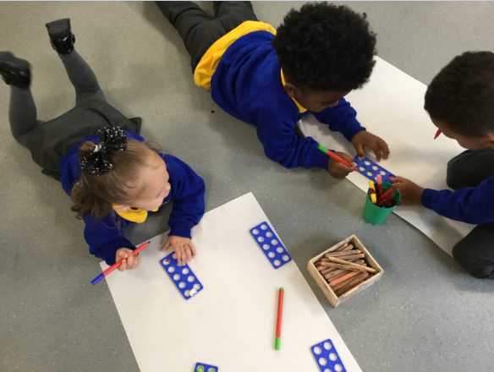

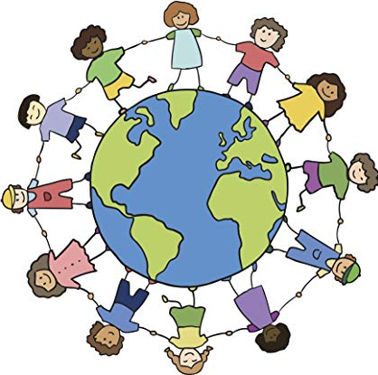
Understanding the World

- Explore construction
- Talk about self and family
- Explore celebrations
- Observe changes in the environment

Physical Development
- To be able to manipulate and show increasing control over objects like threading & cutting
- To show an awareness of safety when using and moving equipment
- To develop good practises in regard to healthy eating
- To develop good practises in self-care

RE
- Explore celebrations:
Diwali
Christmas

Expressive Arts & Design.
- To use tools safely
- Observational drawings/paintings of faces using mirrors
- Explore different materials/ textures
- Explore music, sounds, sing songs & follow a beat
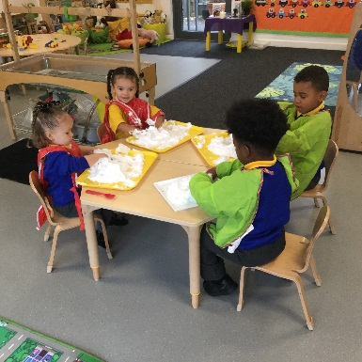
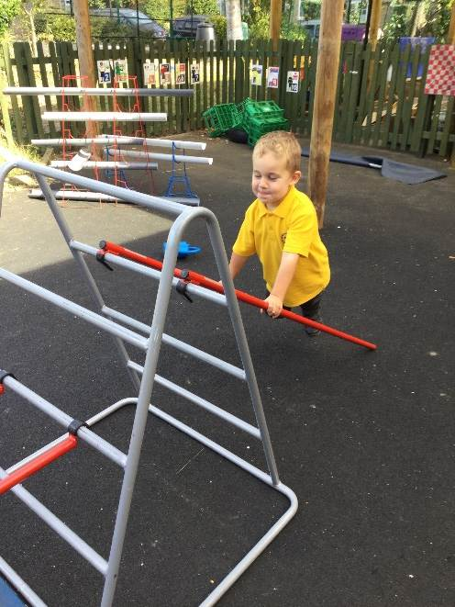
Autumn 1

Literacy (Familiar stories).

- To join in familiar nursery rhymes
- Draw and paint giving meaning to marks
- Phonics games
- Talking about family members
- Stories about different types of families

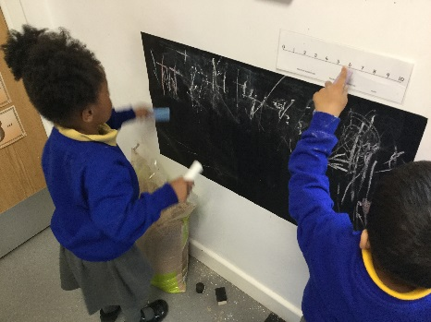

Personal, Social and Emotional Development
- Follow school rules and routines
- Take part in circle time and team activities
- Building positive relationships and new friendships
- Explore new activities and select resources independently
- Talking about themselves and their likes/dislikes

Physical Development.
- Use small and large equipment and one-handed tools
- Promote fine motor control by using threading activities, puzzles and large/ small construction
- Move with control and co-ordination and in a range of ways
- Playing games in the pitch to adjust space , like running, jogging, jelly beans
- Talking about changes in their bodies

