

Weekly Overview – Week Beginning 11.11.19

Here is an overview of some of the activities we will be doing this week.

**‘Fairy Tales’**

This week we are still enjoying our Fairy Tales topic. The book we are reading this week is ‘The Gingerbread Man”. The children will have an opportunity retell the story using puppets, masks and whilst playing with the props in the tuff tray.

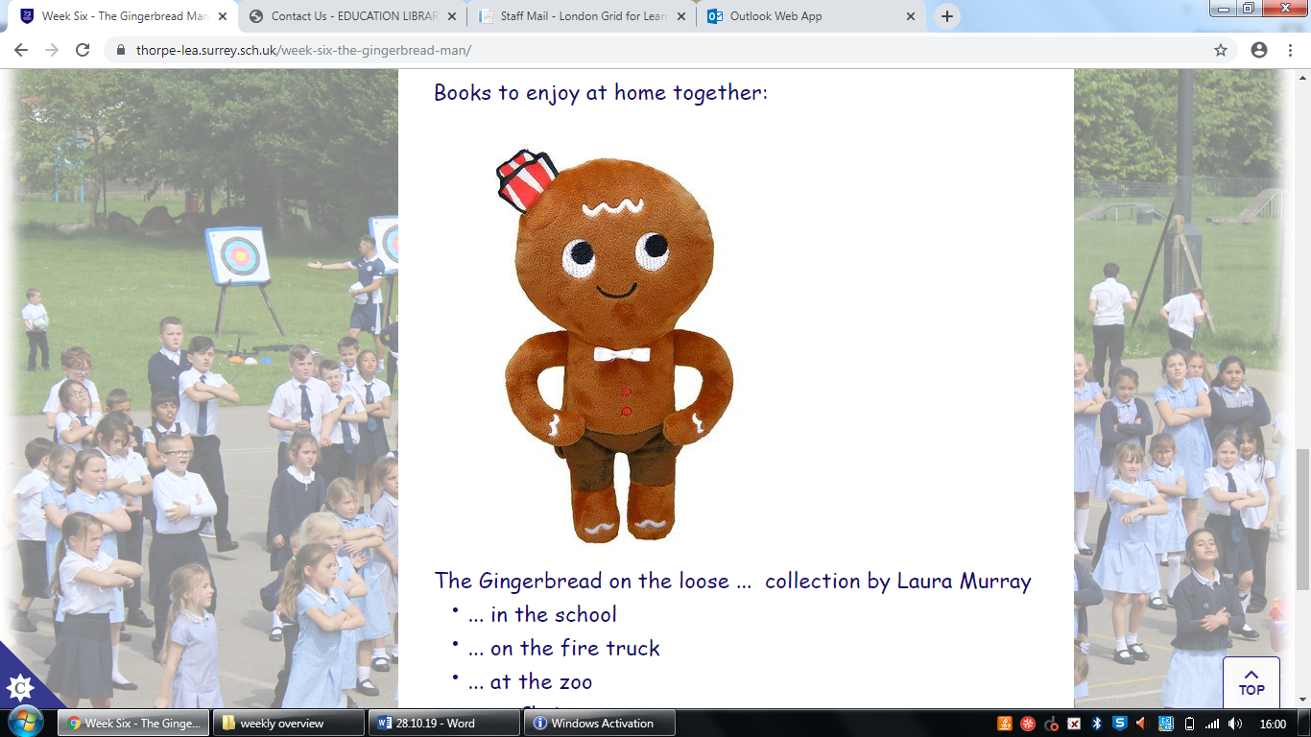

**Maths**

We enjoying learning our numbers through nursery rhymes and ordering them.

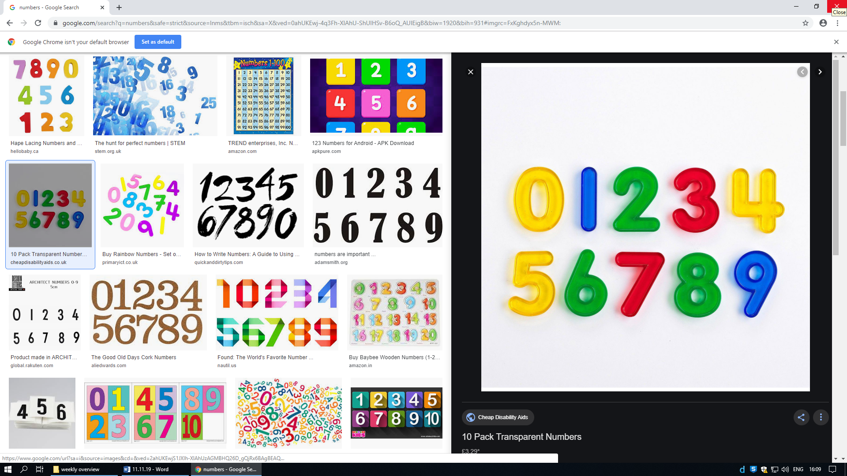

Nursery Rhymes of the week:

Old MacDonald had a Farm

10 Green Bottles

**Literacy:**

We continue to play lot of phase 1 phonics gams and some children have started Phase 2 Phonics sounds. The 2 sounds we are focusing on this week are ‘s’ and ‘a’. We will play lots of fun games to help us to remember these sounds!

