

Weekly Overview – Week Beginning 13.1.20

Here is an overview of some of the activities we will be doing this week.

**‘Transport’**

We‘d like to welcome you back and to wish you a very happy new year!

This half term, we will start our learning journey with exploring different modes of transport. Each week we will learn about a new vehicle and its uses. We have started with fire engines. To help us learn about the importance of firefighters, firewomen will be visiting Pearl class to educate the children about their job and to give lifesaving tips.

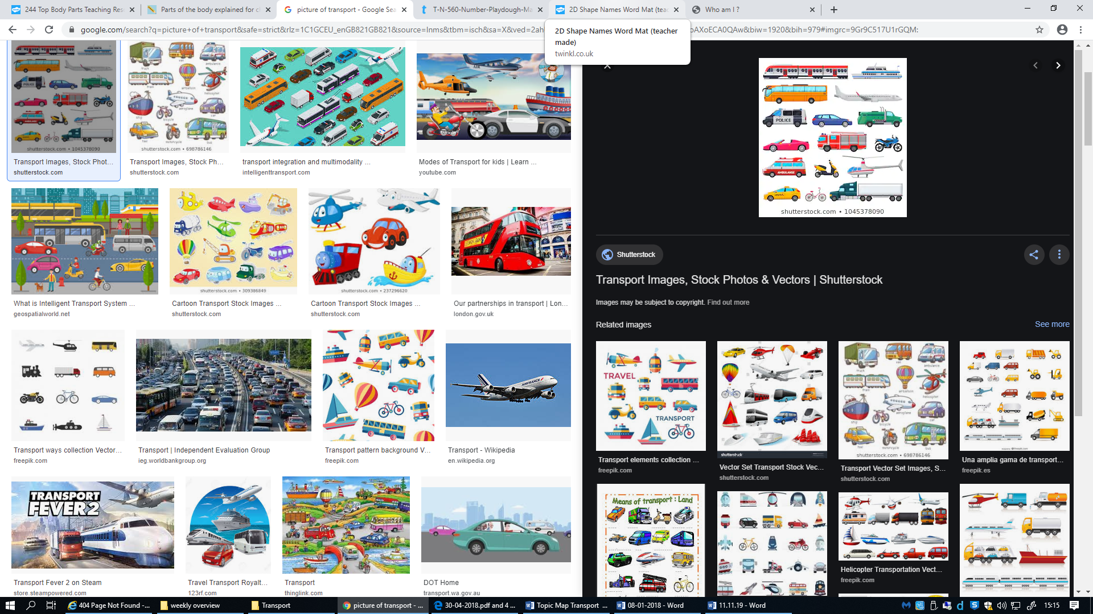

**Maths**

We are enjoying learning our numbers through nursery rhymes and ordering them and counting using 1:1 correspondence.

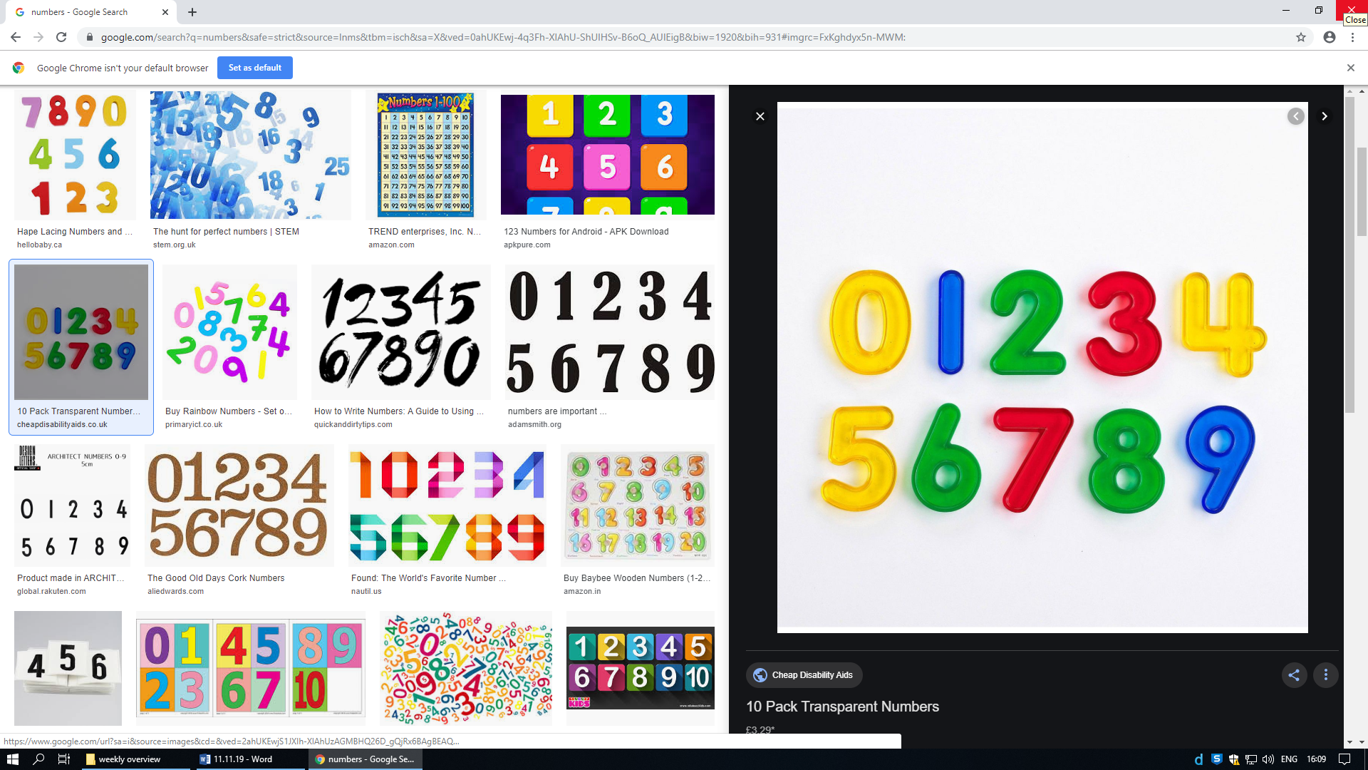

Nursery Rhymes of the week:

1,2,3,4,5 Once I saw

**Literacy:**

We continue to play lots of phase 1 phonics games and some children have started Phase 2 Phonics sounds. The phase 2 sounds we are focusing on this week are ‘n’ and ‘m’. We will play lots of fun games to help us to remember these sounds!

