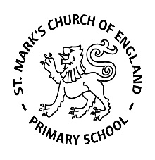

Weekly Overview – Week Beginning 3.2.20

Here is an overview of some of the activities we will be doing this week.

**‘Transport’**

This week we are learning about rockets! The children will be looking at both fiction and non-fiction books about space, we will be making our own rockets using junk modelling and blocks. There will be different areas for the children to explore light and dark using torches. We will also be learning about Neil Armstrong and the first moon landing.

Our focus book is ‘Whatever Next’ by Jill Murphy.

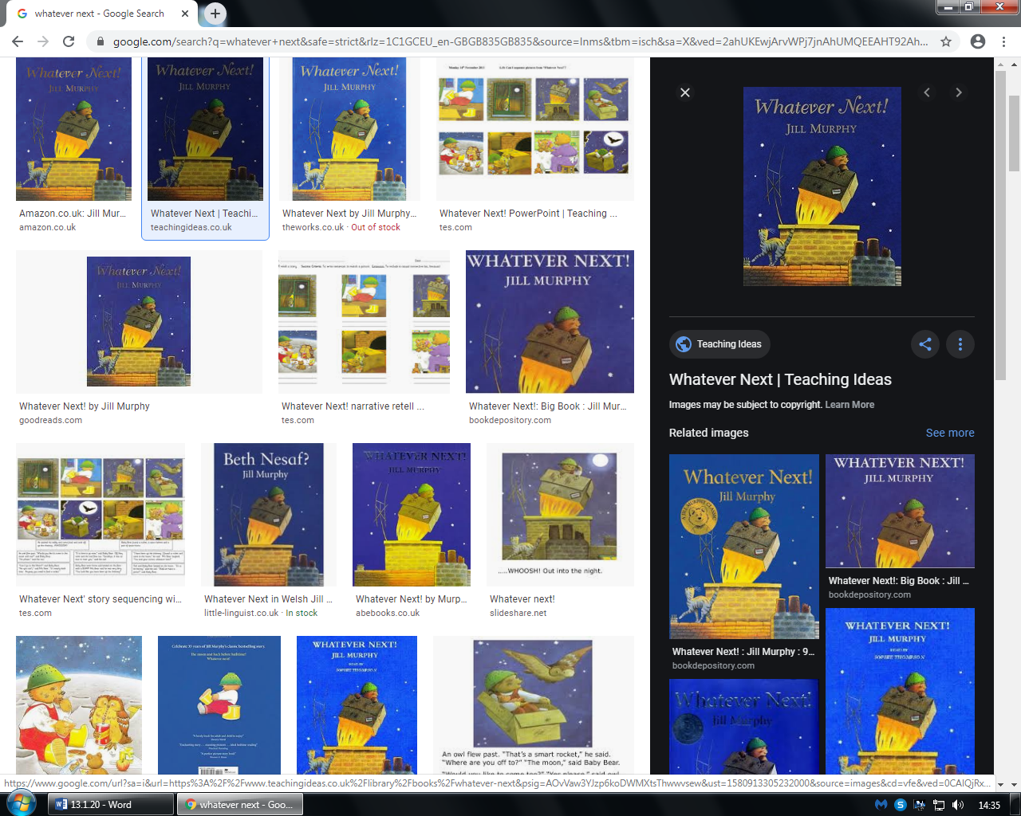

**Maths**

We are still enjoying learning our numbers through nursery rhymes and counting using 1:1 correspondence. Some children are learning about cardinality (how many).

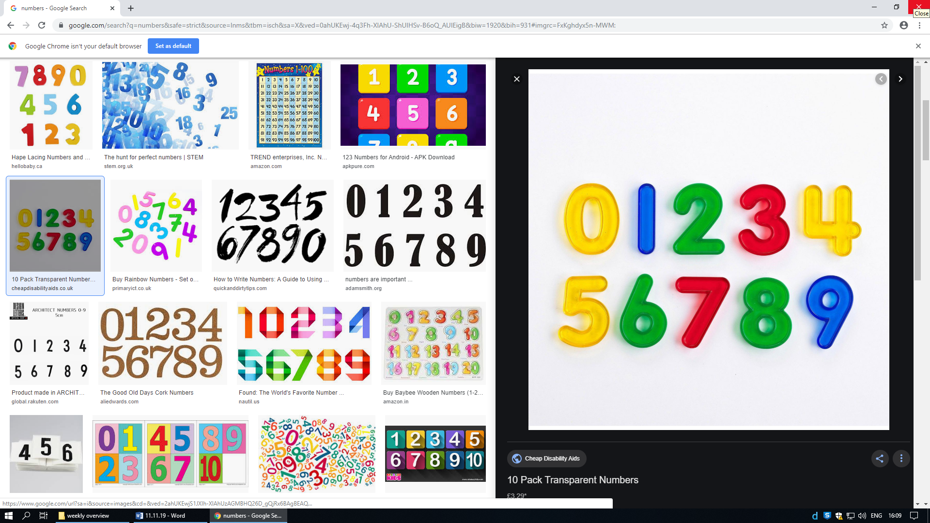

Our nursery song of the week:

Zoom Zoom Zoom!

**Literacy:**

We continue to play lots of phase 1 phonics games and some children have started Phase 2 Phonics sounds. The phase 2 sounds we are focusing on this week are ‘n’ and ‘m’. We will play lots of fun games to help us to remember these sounds!

