Class Teacher: Mr McEleney

Class T.A.: Romy

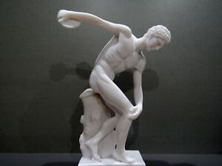

R.E.

This term we We will have PE lessons on a Thursday Afternoon. We will be exploring a range of games and exercise. PE kits will be sent home after every lesson – this will allow washing inline

will be examining Christianity as a faith and what the miracles of Jesus can teach us. We will also be learning about the two natures of Christ. We will be focusing on using the Bible as an aid to our learning.

PSHE

Jet Class will be learning about society, identity and equality. We will look into the idea of stereotyping based on gender. We seek to clarify and explain how prejudice and discrimination can make people feel.

Maths

This term in maths we will be looking to consolidate our knowledge of the number system (place value and big/small numbers); addition and subtraction calculations including algebra; measurement; calculating multiplication and division including algebra; fractions; and statistics.

We will also focus on using formal methods to add, subtract and multiply. There will be a strong focus on problem solving in these areas.

P.E.

We will have PE lessons on Thursday Afternoons. We will be exploring a range of games and exercise. PE kits will be sent home after every lesson – this will allow laundering time.

Computing

Jet class will be exploring the history of computing through the ages, as part of our Digital Literacy Programme.

We will also be working on our Information Technology skills and developing out own vector drawings on Google Drawings.

**Ancient Greece**

**Jet Class**

**Autumn Term**

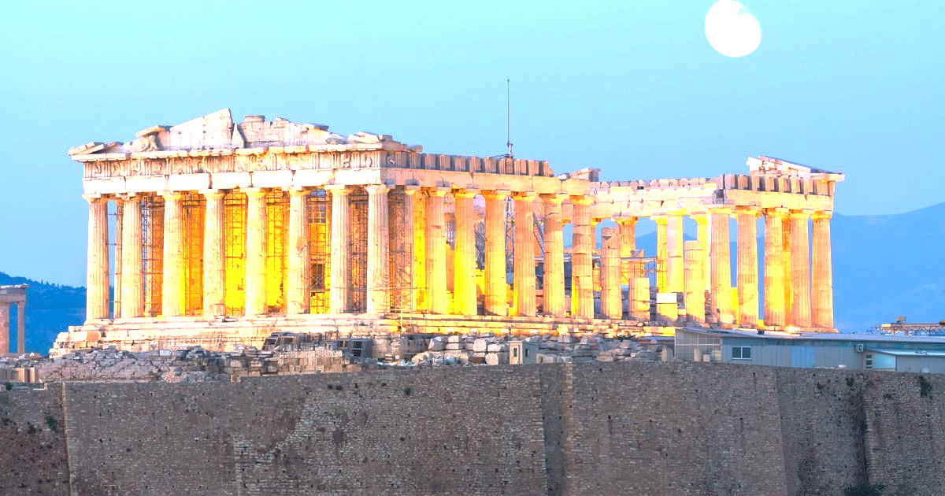

History

This term we are exploring Ancient Greece. We will learn how the Greek empire grew and explore some of the significant events and developments from this period. We will examine early ideas about democracy and how they relate to democracy today. The children will compare recent Olympic Games and the Olympic games in Ancient Greece. We will learn about Ancient Greek religious beliefs - their Gods and Goddesses. We are looking forward to reading and discussing a range of exciting Greek myths.

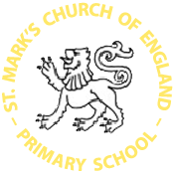

Class Information

PE: Thursday afternoon

Music / Instruments: Monday afternoon

Class Trip: Thurs16th Sept. (Science Museum)

Class Assembly: Mon 4th Oct. 2021

Homework

Homework will be set each Friday and expected back the following Wednesday. Please encourage reading each evening and sign the children’s reading record.

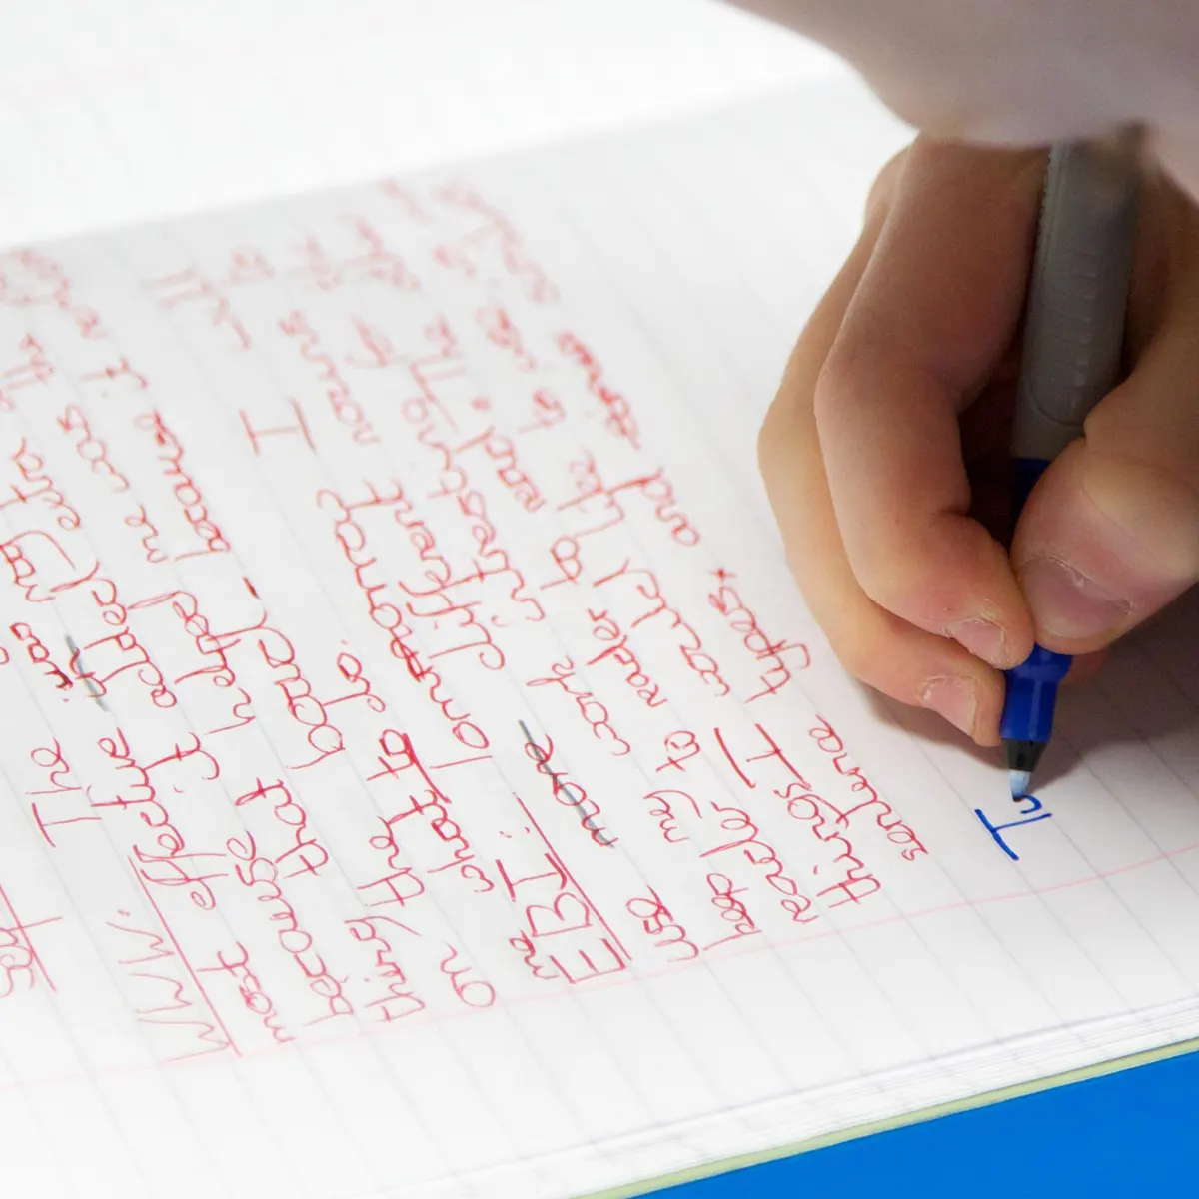



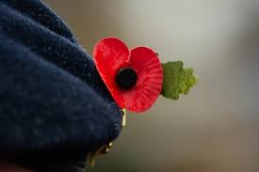

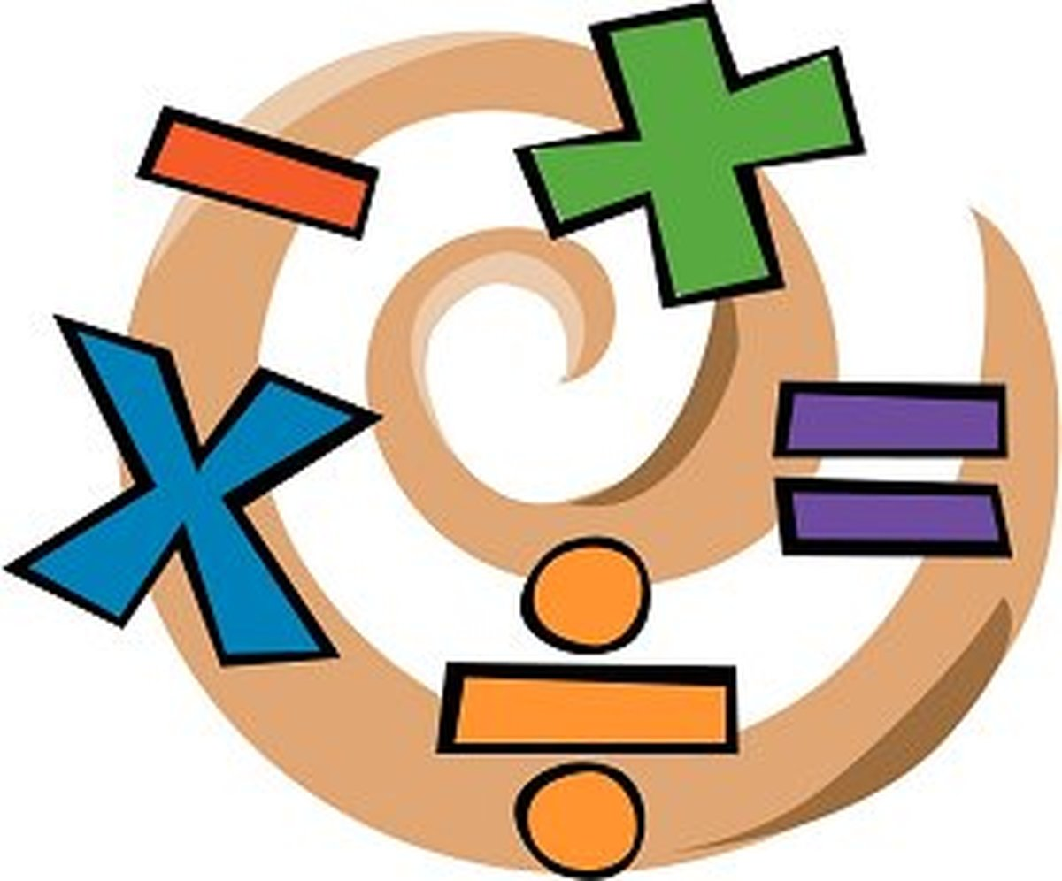

Science

We will be exploring living things and their habitats. This will be linked to our English Stimulus text, on Ernest Shackleton and his trip across the Antarctic.

We will also be studying Earth and Space. We shall be seeking to understand our solar system, the axis of the Earth and countless other fascinating facts that make the Earth and our solar system so special.

English

In Reading lessons,we will continue to make predictions, use inference and deduction to answer questions, clarify meanings in texts, evaluate the quality of texts and make connections using our background knowledge.

To reflect our topics and curriculum, we have cultivated a broad range of stimulus texts. Whilst reading the Adventures of Odysseus, we will create a fictional narrative as well as a speech, we will also be looking at Little Leaders, with an emphasis on black leaders, to coincide with Black History Month. In November, we will be reading the book, Where the Poppies Now Grow, which will ink to Remembrance Sunday! Here we will write a letter from the front.