Desert Class Assembly - Song lyrics

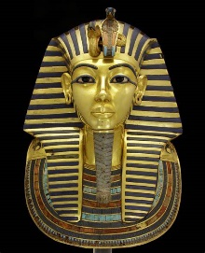
Tutankhamun Song
Many years ago, in the land of the Pharaohs,
A young boy lived, not yet fully grown.
Many years ago, Egypt needed a ruler,
And Tutankhamun ascended the throne.
Tutankhamun, the nine-year-old king,
Tutankhamun, what will the future bring?
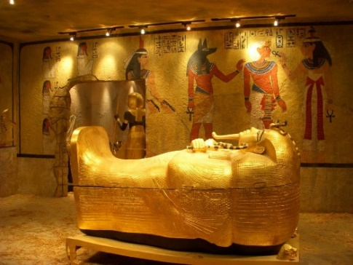
Many years ago in the land of the Pharaohs, the young king said:
‘Who will be my Queen?’
Many years ago, he chose Ankhesenamun,
The bride to be was only thirteen!
Tutankhamun, the nine-year-old king,
Tutankhamun, what will the future bring?
Now, for ten years he reigned over Egypt,
But the boy-king was frail, and he died.
He was buried, along with his treasure.
More than three thousand years passed,
The tomb was forgotten,
With the secrets of the Pharaoh inside …
In nineteen-twenty-two, Carter made a discov’ry:
King Tut’s tomb, buried in the sand.
Suddenly the world knew his face and his name:
The most famous Pharaoh in all of the land!
Tutankhamun, the nine-year-old king,
Tutankhamun, what will the future bring?
Tutankhamun, the nine-year-old king,
Tutankhamun, what will the future bring?
https://www.youtube.com/watch?app=desktop&v=FT5DUuCJkqk

In this together – Ellie Goulding (from 1 minute in)
I can't watch this burn
I can't watch this burn to the ground
You'd have thought we'd learned
You'd have thought we'd learned by now
I can hear the whole world singing together
I can hear the whole world sing, "It's now or never"
'Cause it's not too late if we change our ways
And connect the dots to our problems
I can hear the whole world sing, "We're in this together"
"We're in this together"
Pickin' up the pieces
I listen out for beating hearts
And now it's time for healing
The sun will rise, but this time it's so bright
And all I have left is my faith that we could change
'Cause I can't watch us lose
Like I watch us lose what we found
You'd have thought we'd learned
You'd have thought we'd learned by now
I can hear the whole world singing together
I can hear the whole world sing, "It's now or never"
'Cause it's not too late if we change our ways
And connect the dots to our problems
I can hear the whole world sing, "We're in this together"
"We're in this together"
Oh, oh
Oh, I can hear the whole world singing together
And I can hear the whole world sing, "It's now or never"
'Cause it's not too late if we change our ways
And connect the dots to our problems
I can hear the whole world sing, "We're in this together"
"We're in this together"

https://www.youtube.com/watch?v=NE3jQjM-bus (from 1 minute in)

In the desert (to the tune of the mighty jungle)

EE-E-Oh- Mum A Wah
A-wimoweh, A-wimoweh, A-wimoweh
A-wimoweh, A-wimoweh, A-wimoweh

In the desert the mighty desert the camel rides all day
In the desert the quiet desert the camel rides all day

A-wimoweh, A-wimoweh, A-wimoweh
A-wimoweh, A-wimoweh, A-wimoweh

Near the river the peaceful river the meerkat lies in wait
Near the river the peaceful river the meerkat lies in wait

A-wimoweh, A-wimoweh, A-wimoweh
A-wimoweh, A-wimoweh, A-wimoweh

Hush my darling no fear my darling
The desert’s cold at night
Hush my darling no fear my darling
The desert’s cold at night
https://www.youtube.com/watch?v=KZ8beg31zyQ

https://www.youtube.com/watch?v=Pt9R8UJ379c (instrumental)

