Opal Class Assembly - Song lyrics

Walk like an Egyptian
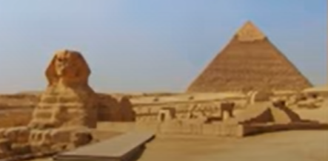
In Ancient times, Egyptians were cleverly building pyramids.
Enormous tombs (oh ay oh) and covering them in hieroglyphs…

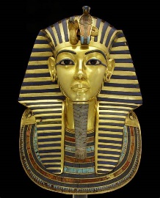
Tutankhamun, young pharaoh, discovered in Valley of the Kings.
Canopic jars (oh ay oh) surrounded by gold an’ loadsa bling!

Kings and their dynasties say…
(Way oh way oh, oh way oh way oh)
Walk like an Egyptian…

Those dead pharaohs packed in salt an’ bits removed to be mummified.
Then afterlife (oh ay oh) a journey across the River Nile…
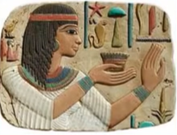
Egyptian art was so smart, the people were all in silhouette.
Egyptian gods (oh ay oh) Anubis and Horus and the rest.

Kings and their dynasties say…
(Way oh way oh, oh way oh way oh)

Walk like an Egyptian…
Repeat all

Walk like an Ancient Egyptian! - YouTube

The Gift of the Nile

We were travelling in packs, we were hunter gathers…
searching for animals, plants and fish to eat
Over time we learned of agriculture, so the Nile River is where we’d want to be
and we changed the land by building canals, allowing us to control water
The system of irrigation gave us lots of food

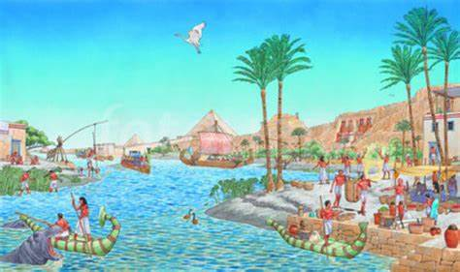
But WOOOOOHHH to the gift of the Nile
The floods would bring us black silt
Spreading fertile soil throughout Egypt
WOOOOOOHHHH WOOOHH to the gift of the Nile
Every year the floods would repeat… bringing life throughout Egypt
WOOOOOOHHH WOOOHH to the gift of the Nile

Every year like clockwork the floods would come and spread the black silk
Now the Nile flows from the South to the North
First it’s gonna flood in upper Egypt
And it gave everything the farmers would need, making land useable for farming
Without the Nile River no one would survive
So WOOOOOHHH to the gift of the Nile
The floods would bring us black silt
Spreading fertile soil throughout Egypt
WOOOOOOOOHHHH WOOOHH to the gift of the Nile
Every year the floods would repeat bringing life throughout Egypt
WOOOOOOOOHHH WOOOHH to the gift of the Nile
Ancient Egypt The Gift of The Nile - How the Nile impacted Ancient Egypt Song for kids - YouTube (Play back speed 0.75)
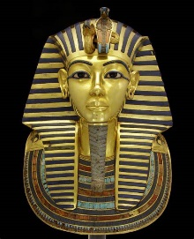
Tutankhamun Song
Many years ago, in the land of the Pharaohs,
A young boy lived, not yet fully grown.
Many years ago, Egypt needed a ruler,
And Tutankhamun ascended the throne.
Tutankhamun, the nine-year-old king,
Tutankhamun, what will the future bring?
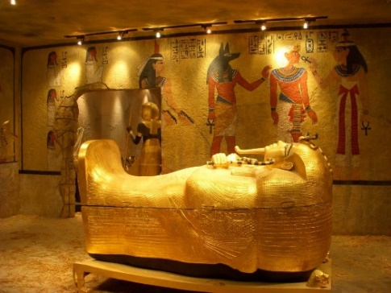
Many years ago in the land of the Pharaohs, the young king said:
‘Who will be my Queen?’
Many years ago, he chose Ankhesenamun,
The bride to be was only thirteen!
Tutankhamun, the nine-year-old king,
Tutankhamun, what will the future bring?
Now, for ten years he reigned over Egypt,
But the boy-king was frail, and he died.
He was buried, along with his treasure.
More than three thousand years passed,
The tomb was forgotten,
With the secrets of the Pharaoh inside …
In nineteen-twenty-two, Carter made a discov’ry:
King Tut’s tomb, buried in the sand.
Suddenly the world knew his face and his name:
The most famous Pharaoh in all of the land!
Tutankhamun, the nine-year-old king,
Tutankhamun, what will the future bring?
Tutankhamun, the nine-year-old king,
Tutankhamun, what will the future bring?
Year 3 Assembly - Tutankhamun Song - YouTube

