

**Our upcoming class assembly will focus on this term’s topic, ‘Space’.**

**The children will need to wear a space suit on two separate occasions.**

**The class visit to space, Friday 10 March 2022**

**For the assembly on Tuesday 21 March 2022**

**Use your artistic skills and have fun creating a space suit with your child.**

**Follow the link below for simple steps on making an amazing space suit.**

<https://7daysofplay.com/diy-astronaut-costume/>

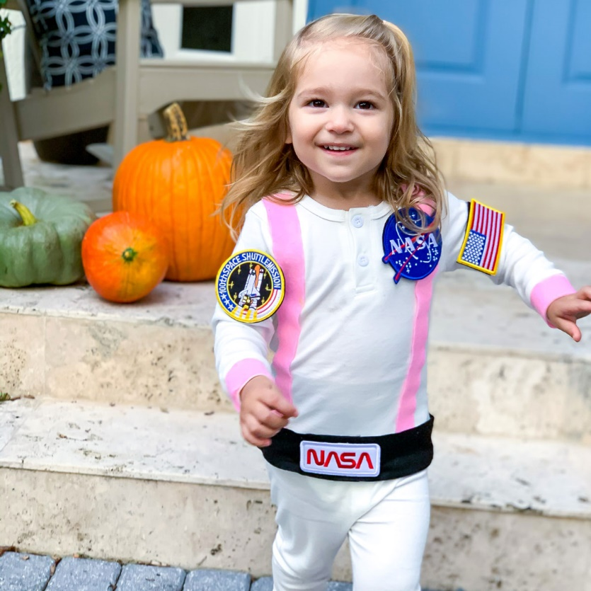 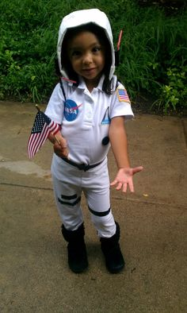

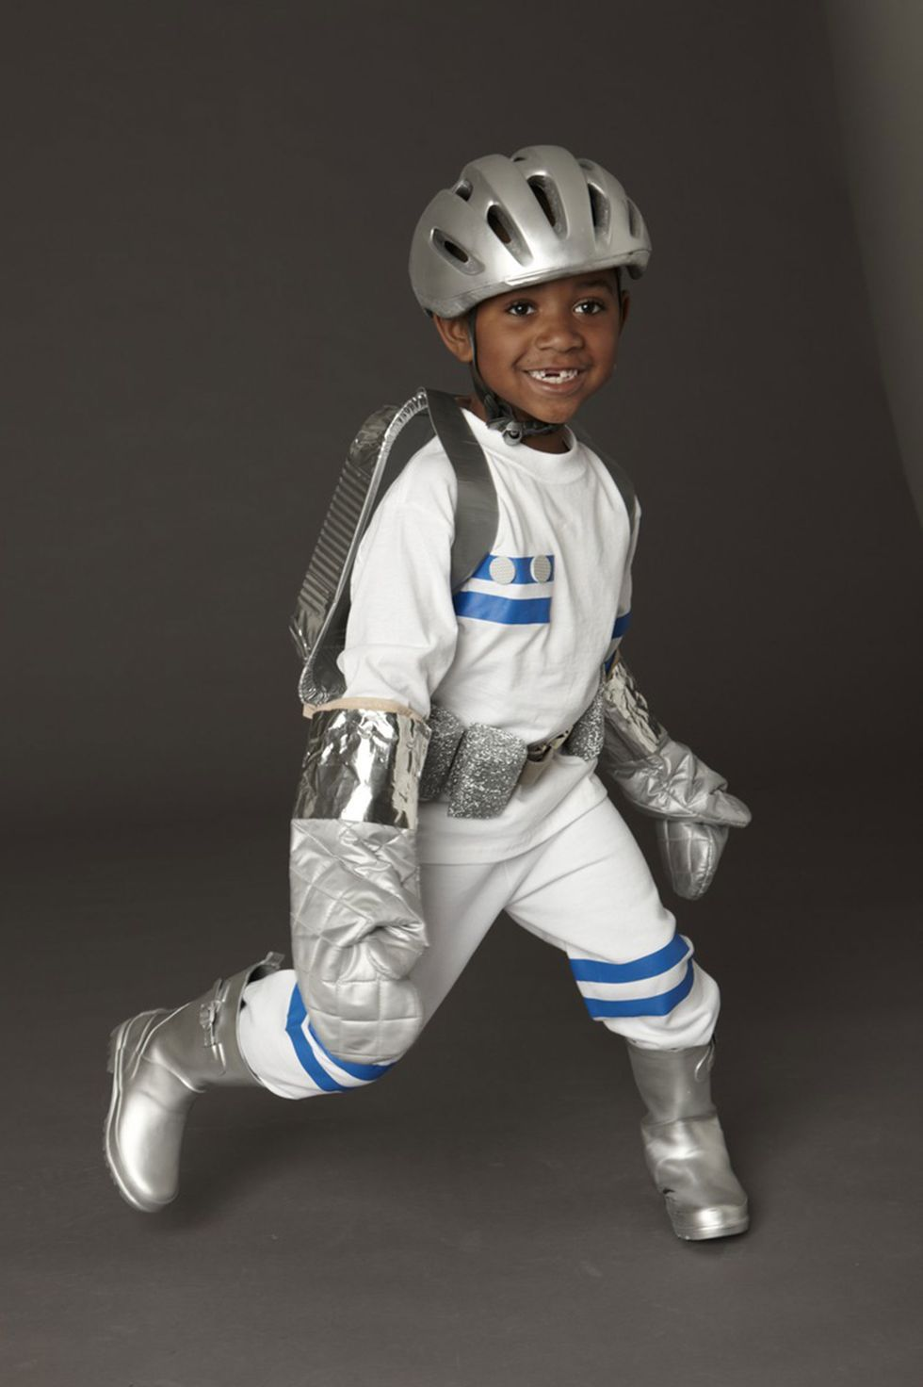 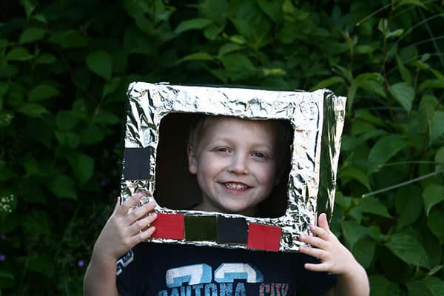

**DIY Astronaut Costume**