Reading | Enjoy reading with an adult or sibling over the holidays. It would be great to share a story each night before bedtime.
Phonics | Play lots of phonics games and reread those ‘Red’ words to keep them fresh in your memory | 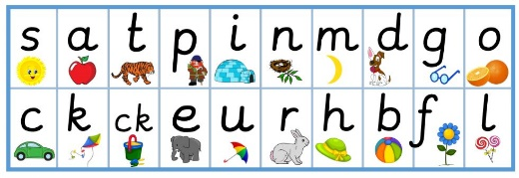
Writing | There are lots of things you can write about over the holidays  Here are some ideas.  - Write a diary  - Write a story  - Write a postcard | 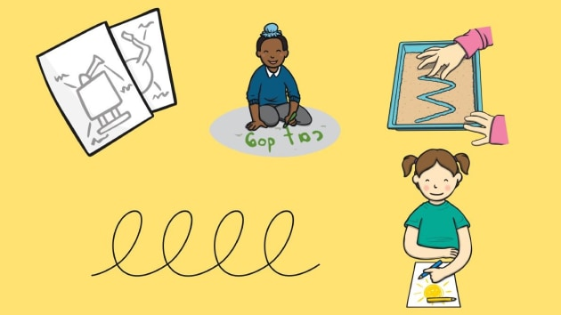
Creative | Can you create a masterpiece?  - A painting  - A drawing  - A sculpture
Let’s Talk | Talk about the exciting adventures you will have in Year 1  What are you looking forward to?  Is there anything that you are afraid of?
Keep Fit | Remember to get lots of fresh air and exercise. Jog, hop, run, climb and enjoy!

Wishing you all a happy safe holiday.

